

**Sneak Peek**

**Can you survive the dangers?**

**Vincent Cheung**

**Bachelor of Electronic & Computer Engineering**

**Galway-Mayo Institute of Technology**

**2016/2017**

**Supervisor:** Paul Dunne, Galway-Mayo Institute of Technology

# Poster

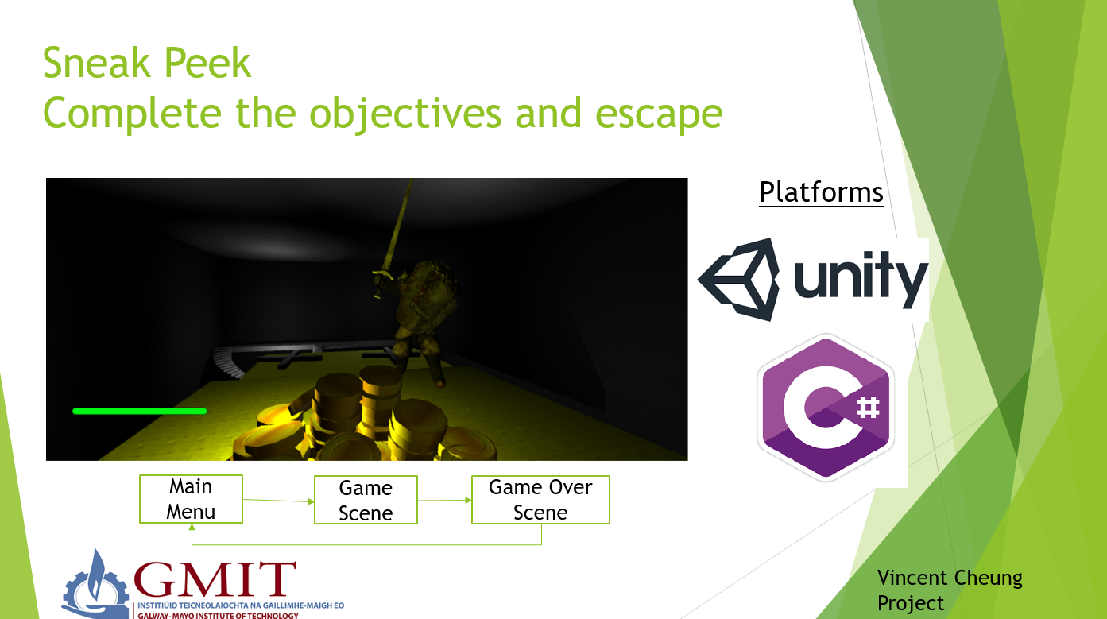

# Declaration

This project is presented in partial fulfilment of the requirements for the degree of Bachelor of Engineering in Computer & Electronic Engineering at Galway-Mayo Institute of Technology. This project is my own work, except where otherwise accredited. Where the work of others has been used or incorporated during this project, this is acknowledged and referenced.

# Acknowledgements

I would like to thank all those that provided the help for the possibility to complete this report. A special gratitude I give to my project supervisor Paul Dunne, who helped me with my project and gave me pointers on how I should proceed with my project. As well as that he gave me tips and told me how I should explain my project and was very helpful overall on how I should be more confident when I talk about Unity.

Furthermore, I would like to acknowledge my classmate Alex Brown in assisting me as well as giving me tips and pointers for my project, he was also the one that gave me the idea to use Unity for my project.

Table of Contents

Poster 2

Declaration 3

Acknowledgements 4

Summary 7

1. Introduction 8

1.1 Project Description 8

1.2 Project Goals 8

1.3 Features of Project 9

1.3.1 First Person Camera 9

1.3.2 Stealth and Detection 10

1.3.3 Player Health and Death 11

1.3.4 Non-player character 12

1.3.5 Traps and Enemies 13

1.3.6 Objectives 14

1.3.7 Levels and Design 14

1.3 Technology Used 16

1.4 Introducing Unity 16

1.4.1 Ease of using Unity 16

1.4.2 Development Costs 17

1.4.3 Why use Unity 18

1.5 Project Requirements 18

Project Creation 19

Problems Encountered 26

Scripts 29

ZombieTransition.cs 29

Sun.cs 30

StopMove.cs 30

RotateTrap.cs 31

Player.cs 32

Pickup.cs 33

LoadScene.cs 34

Fade.cs 34

FirstPersonController.cs 35

ButtonManager.cs 40

CharacterHealth.cs 40

Architecture Diagram 41

Conclusion 42

References 43

Unity Store Assets and Libraries Used 44

Assets 44

Libraries 45

# Summary

The intended audience for this project are for any fellow students as well as anyone that has an interest in game development in general or those that want to learn a new skill.

The goal of this project is for the student’s 5th year project; it is a game made in the Unity Game Engine. The game will be a 3D “stealth game” where the main objective for the player is to avoid detection from the enemies and finding the exit point of the level.

The key features of this project are the new things that the student will be required to research and learn such as C#, level design, working with AI.

The way the student will have to approach this project is by first make the basics of a game, to do that he has to construct his levels, add in the game mechanics, add in his characters, add in his physics components such as gravity, collision detection and more.

The main technology used in this project is Unity; Unity is a game development platform that can be used to make both 2D and 3D games, for many types of platforms such as desktop, VR/AR, consoles and even mobiles. The user has an option to use either JavaScript or C#. The student went for C# as it is the most like Java which is a programming language that the student has used for a few years.

The student managed to accomplish most of the game mechanics that he wanted for his game. The student thinks that he managed to accomplish most of the things he wanted for the game, if the student was to use Unity again it would be to make another type of game.

# 1. Introduction

This is a proposal for a final year degree project at The School of Engineering GMIT;

This project aims to solve various problems for young people mainly boredom and wasting money on triple A titles, if the project is successful the student hopes to keep on working on the game in their spare to time to expand the game. This project will be a game created using Unity; it’s a free to use game engine if you don’t get more than $100,000 profit from the game. The student hopes to learn how to follow a Gant chart and abide by deadlines that was set for themselves as this will be very useful in the working world as well as that gaming is one of their hobbies and working on a hobby is better than working on something you have no interest in. The student also wishes to learn more about game development such as the requirements there are to get a basic game going. The course that the student is studying is B.Eng.(Hons) Computing and Electronic Engineering, the student hopes to pass the course and learn about how to use Unity. The college is situated at Dublin Road, Galway. The project must be completed as a final year project assigned to all the students in that year and course.

## Project Description

The project that the student will create is a game made in the Unity Game Engine, the game will be a 3D “stealth game” with elements focusing on hiding and avoiding detection. The student will have to create stages that a player will have to navigate through and complete objectives to complete the stages, this will use the Unity Game Engine. As well as that the student will be required to create and design their own characters for the game such as the player’s character as well as the enemies in the game or any other extra characters. The student will avoid making the game as linear as possible and there hopefully be multiple ways for a player to complete the stage.

## 1.2 Project Goals

The goal of this project is to submit a suitable 5th year project for the student’s B.Eng. (Hons) Computing and Electronic Engineering project module. The student wants to learn more about Unity and more about game development. The student has an interest in this field. The student hopes by doing a project on game development he will learn about the requirements there are to make a game from scratch using Unity as well as that the student wants to learn C# as that is something the student has not used before. Although it is very like Java there are some minor differences.

## Features of Project

There are various features in the project and they are first person camera, , visual detection and chasing, player health and death, game over scene, a non-player character, enemies and traps, ending screen, objectives and levels and design, these topics are explained in more detail below.

### 1.3.1 First Person Camera

The primary feature of the project will be a 3D game using the Unity Engine, the player will be able to run around like in a real world setting and not be limited like a 2D game. The player will be controlled in a first person setting, that is, the player will experience the game through the eyes of the in-game character. The controls for the character is the standard WASD for movement and the mouse to look around.

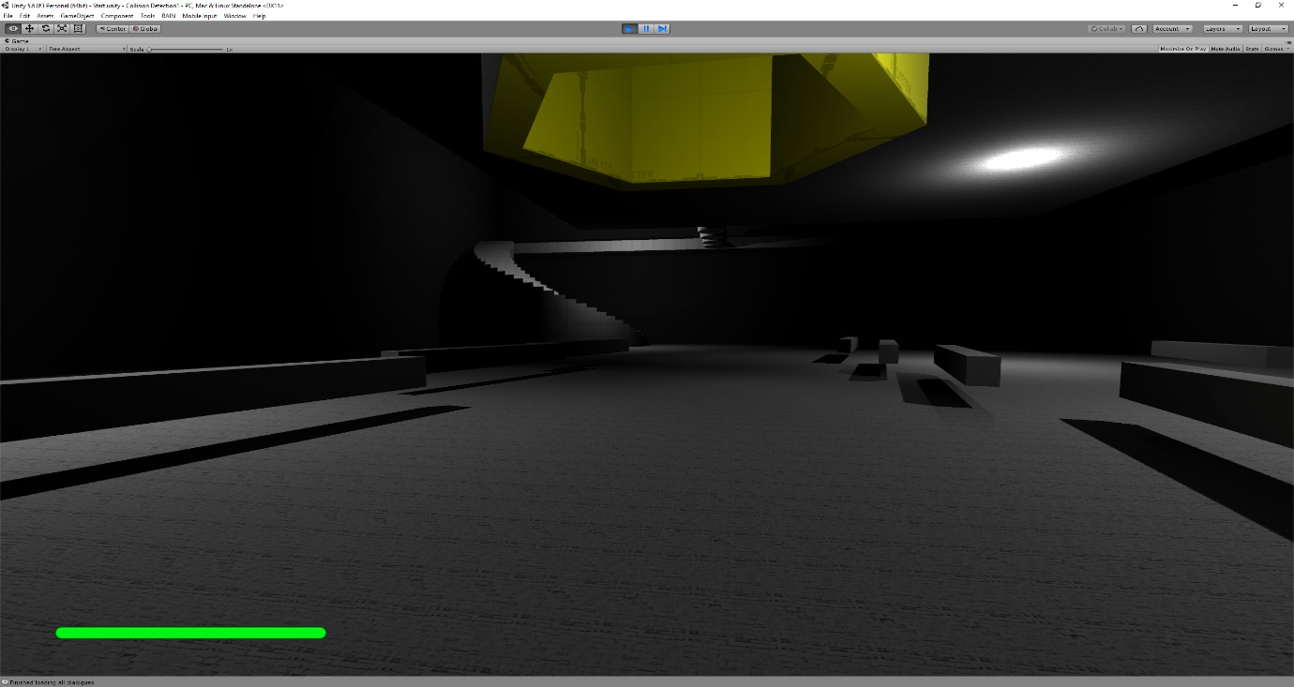

### 1.3.2 Stealth and Detection

The game will be stealth focused, this means the player will need to avoid detection from the enemies; the enemies are quite powerful and can deliver a crushing attack that can kill players quite fast, but these enemies only appear at the latter levels not at the start of the game. At the start of the game there’ll be traps in the games that the player will need to avoid. These traps will be deadly and getting hit by them too many times will result in the player dying. The screenshot below shows the enemy’s vision range, when the player enters it, the monster will start chasing the player. The monster moves at a slightly slower speed than the player so the player can out run it if they run straight, but if they try to strafe run the monster can catch up to the player.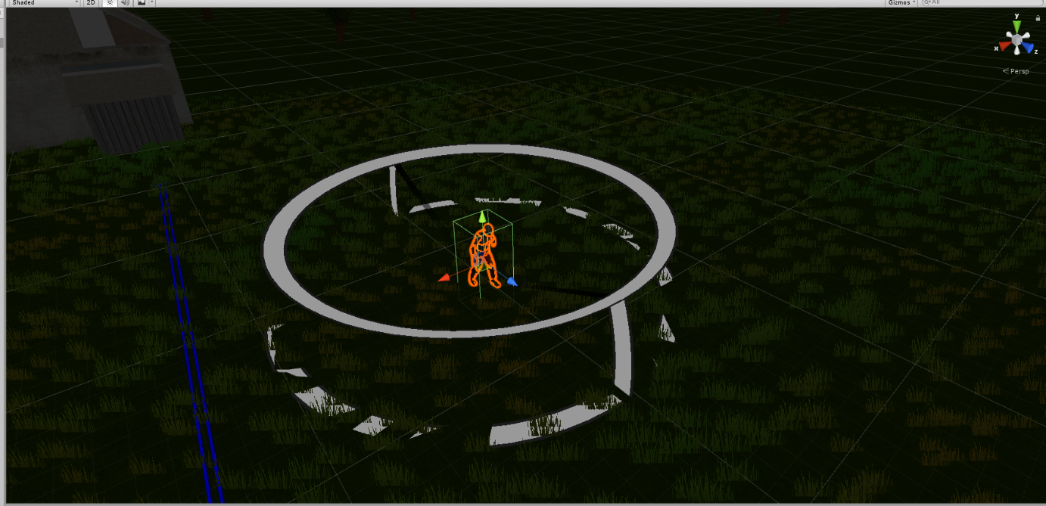

## 1.3.3 Player Health and Death

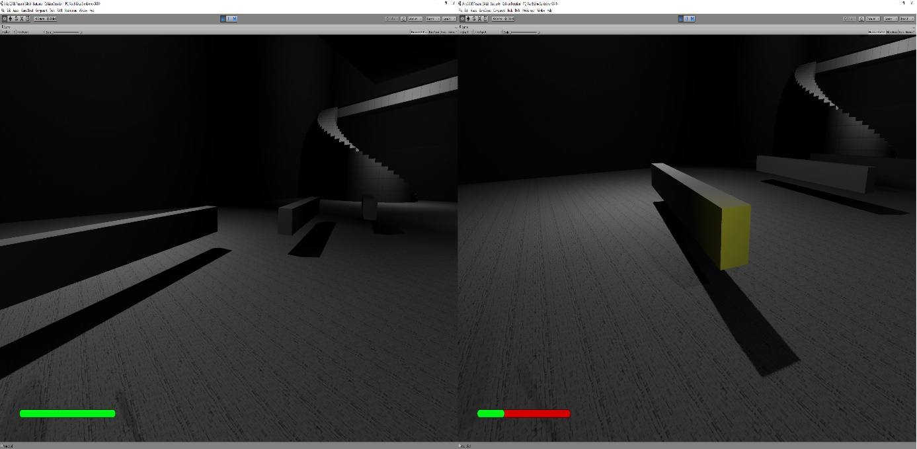

In the above screenshot, you can see a green bar, this is the character’s health; the more green there is on the health bar the more healthy the player is, in the event that the player gets hit by the trap the player’s health decreases denoted by the red, the picture on the right, above. When the player loses all his health a game over screen appears, screenshot below – This screen allows a player to select what level the player wants to replay as well as that there’s a credits scroller which shows the main level designer and programmer for this game. When the player is done he can also select “Exit” to quit the game. Exit is only available for players in the executable version of the game, as there is nothing to exit on when you’re testing the game in Unity.

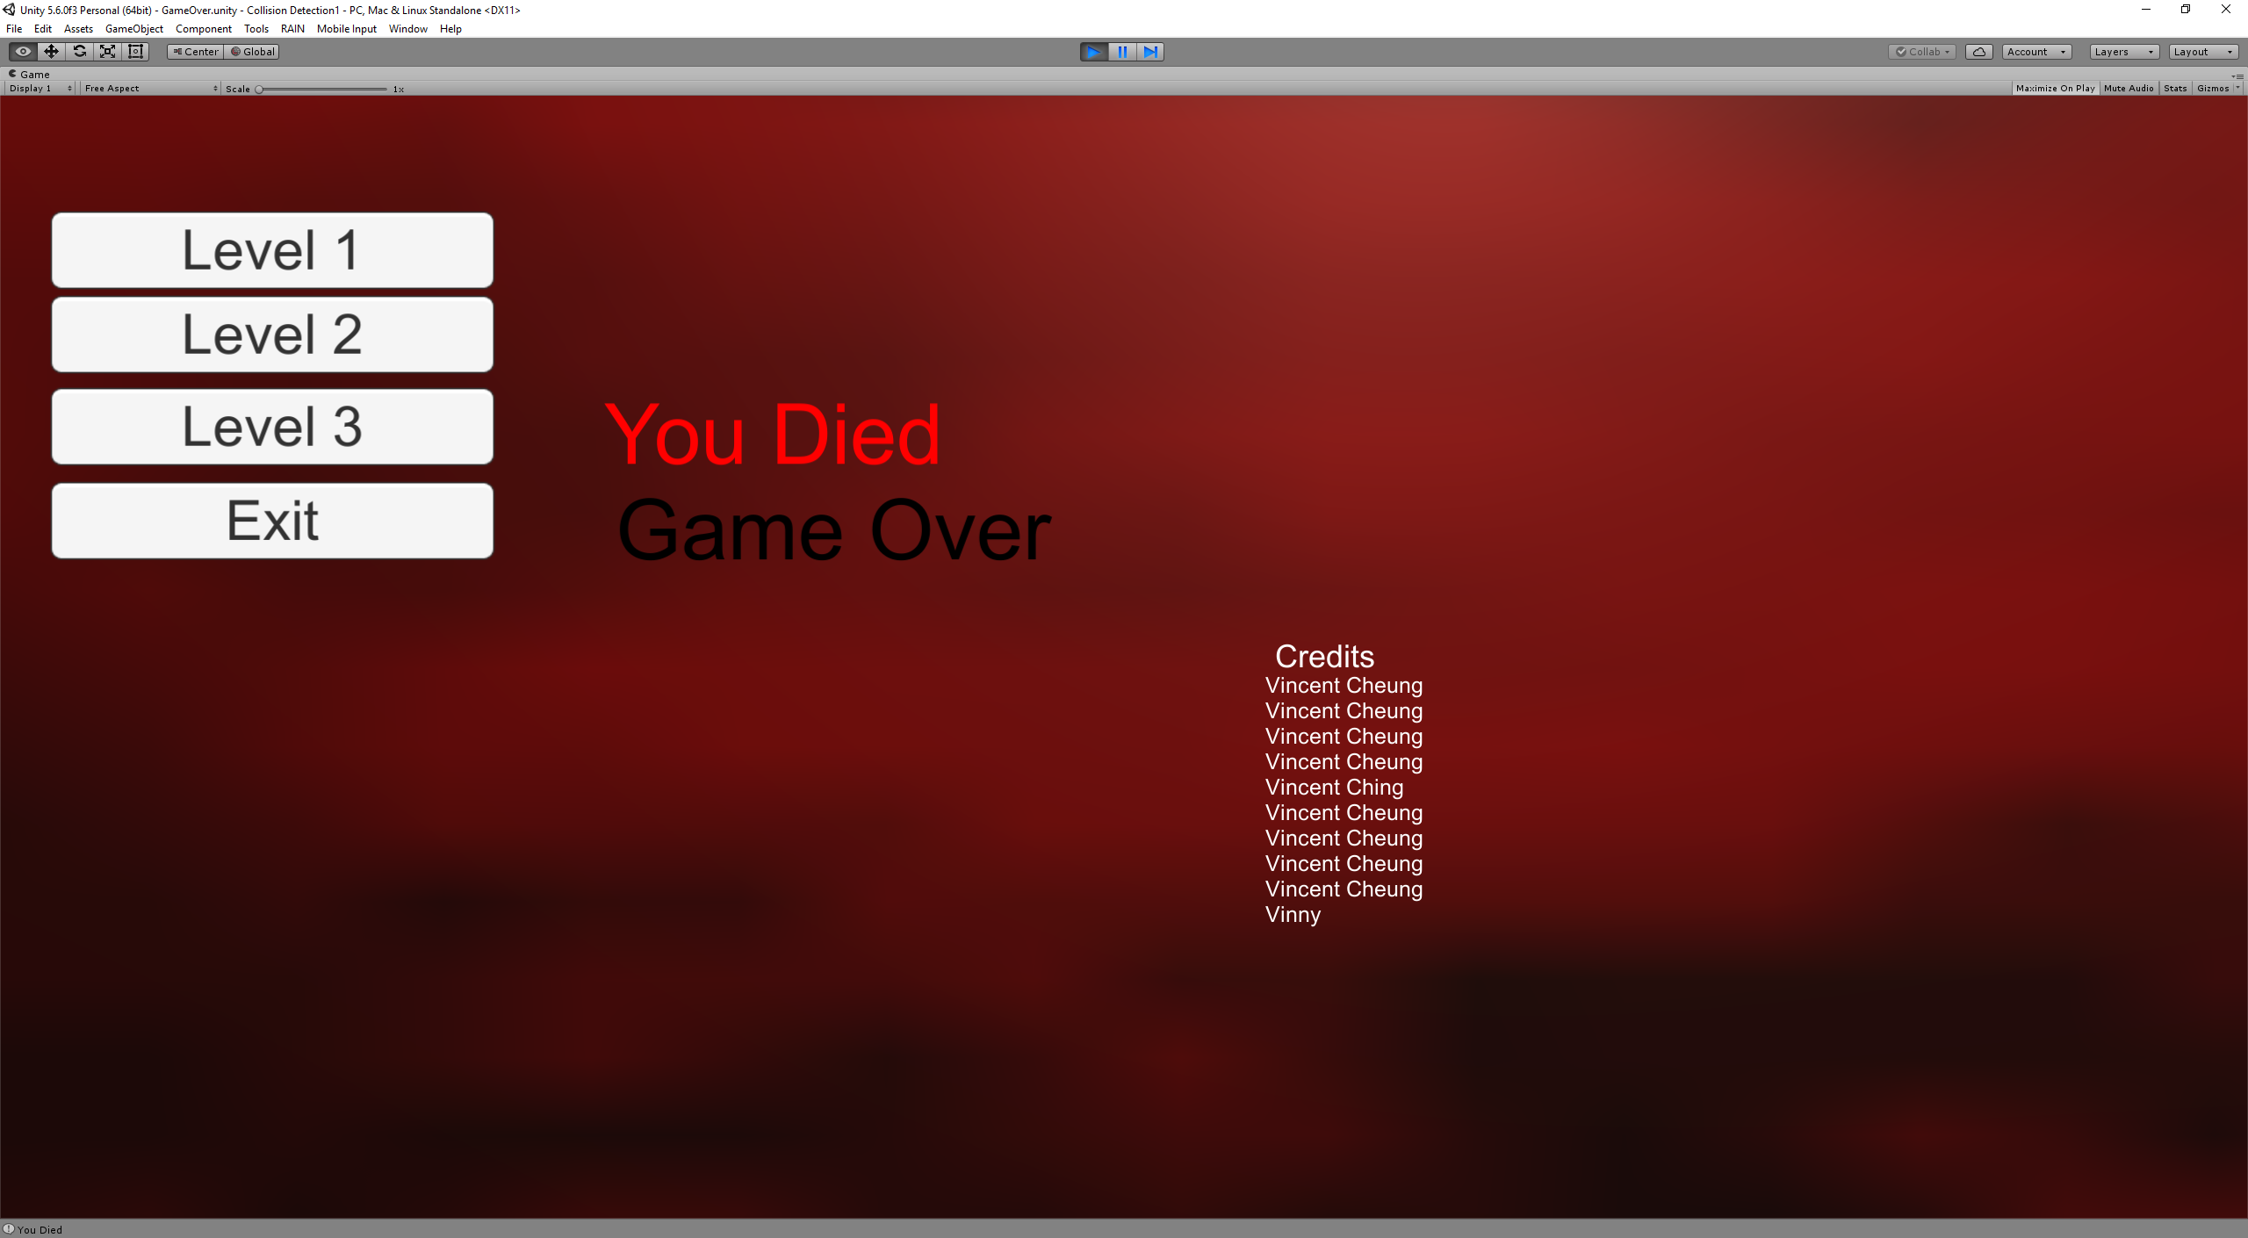

### 1.3.4 Non-player character

The game has a non-player character, this character dubbed “Shrunk Knight” at the first level gives advice to the player to tell him what the player should do to progress to the next level but as the player progresses the NPC will become more secretive and the player will need to figure out the requirements to progress to the next stage from his dialogue. To interact with this non-player character the player needs to walk up to him and press the “E” button to start talking with him.

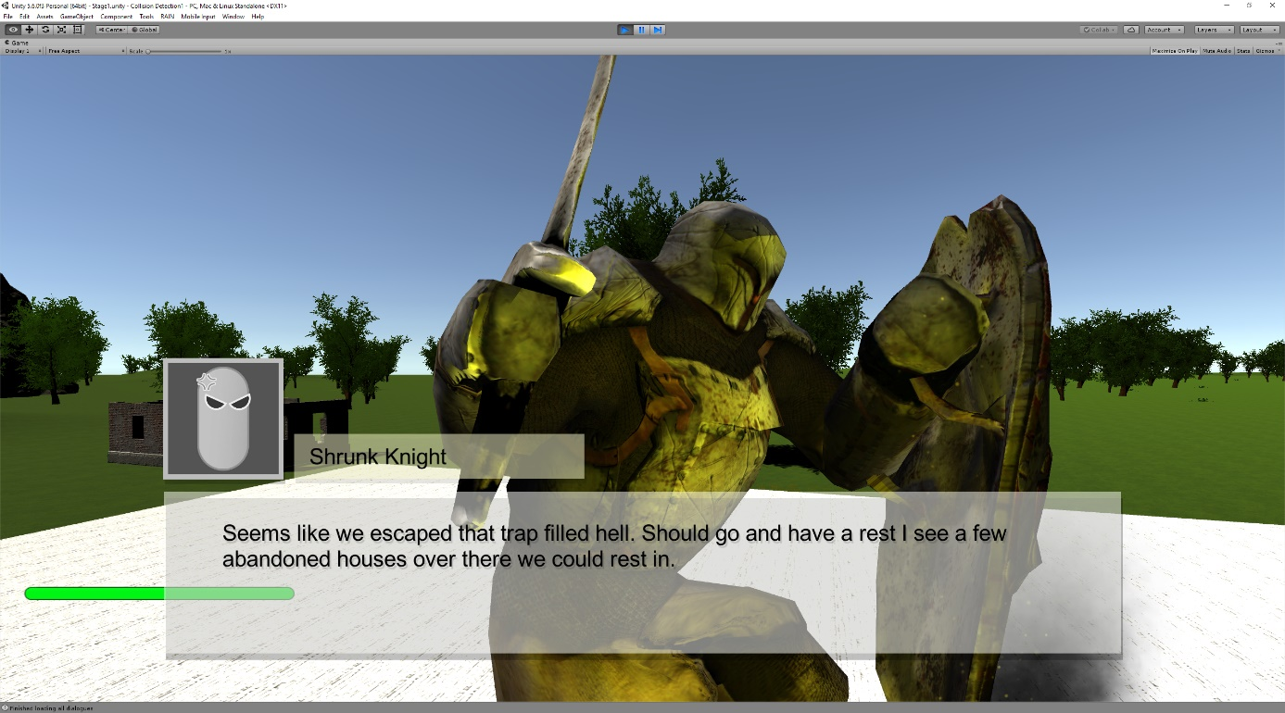

As shown in the screenshot above the non-player character tells the player where to go to progress to the next level but as shown in the screenshot below the non-player character does not actually tell the player what he needs to do 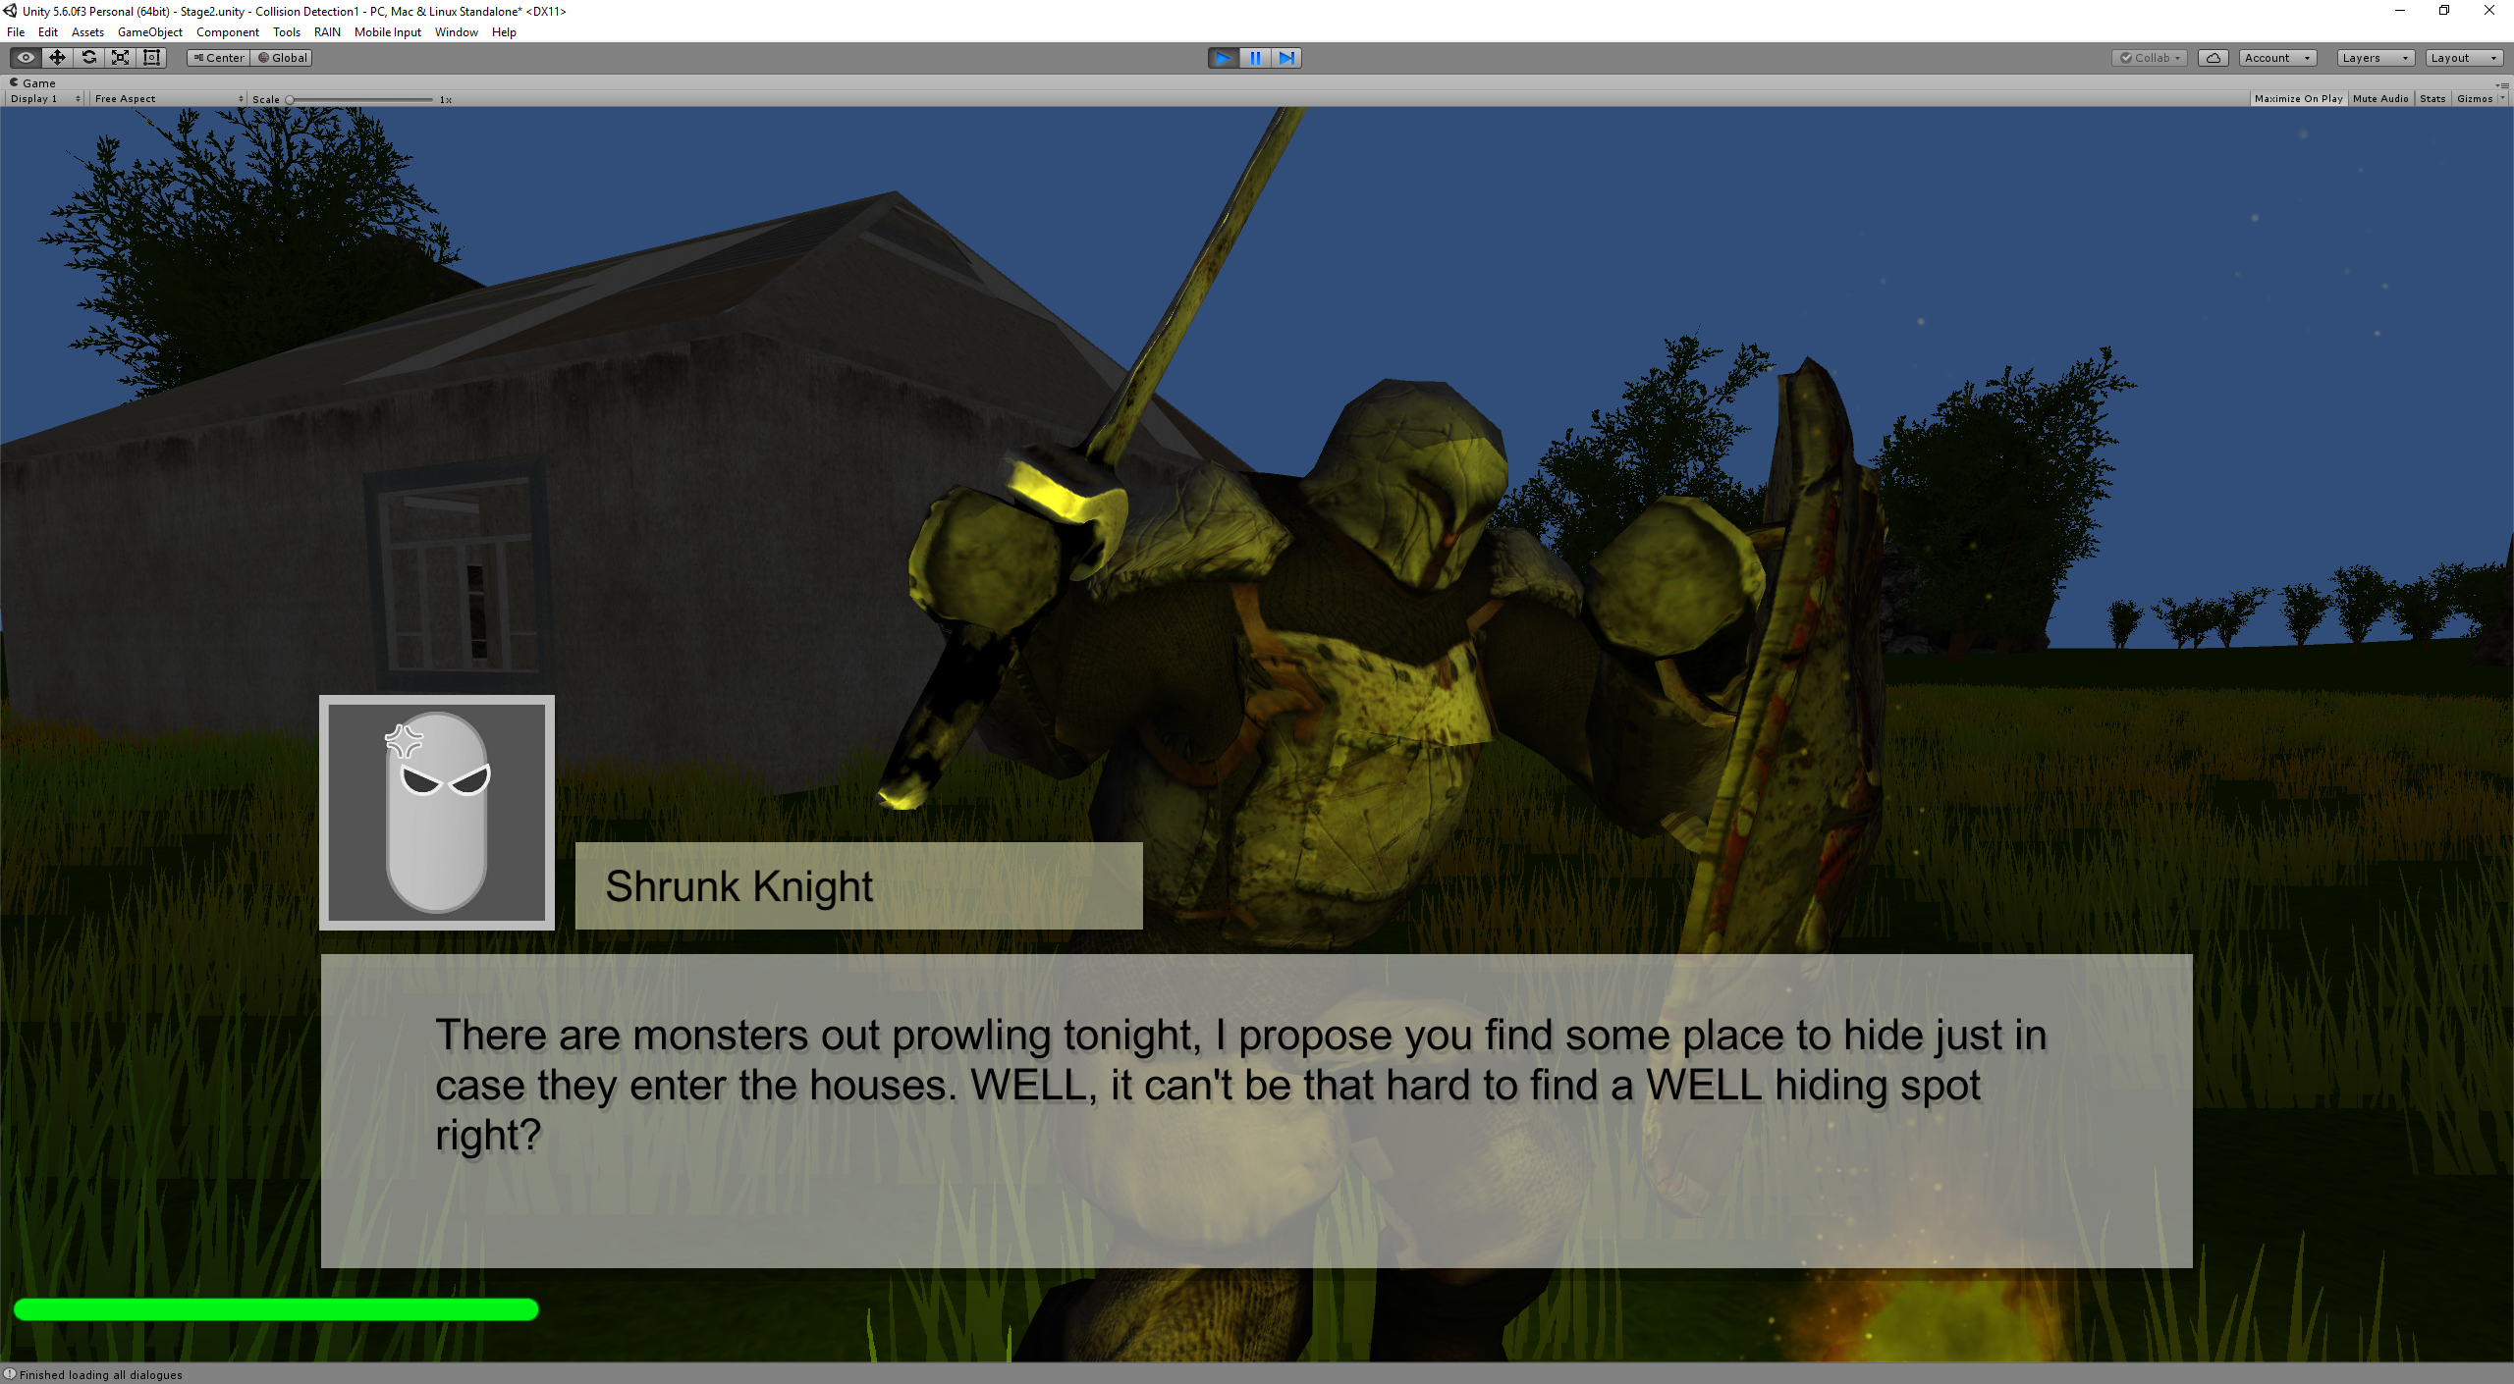

### 1.3.5 Traps and Enemies

There are various hazards in the world. Below you can see the monster that stalks you at night on the right. On the left you can see the traps, these traps rotate at high speeds and if the player gets too close to them they’ll start to hurt the player. Both the trap and monster are the only hazards that can kill a player but it is more than enough. The monster is animated through Unity’s Mecanim animation system.

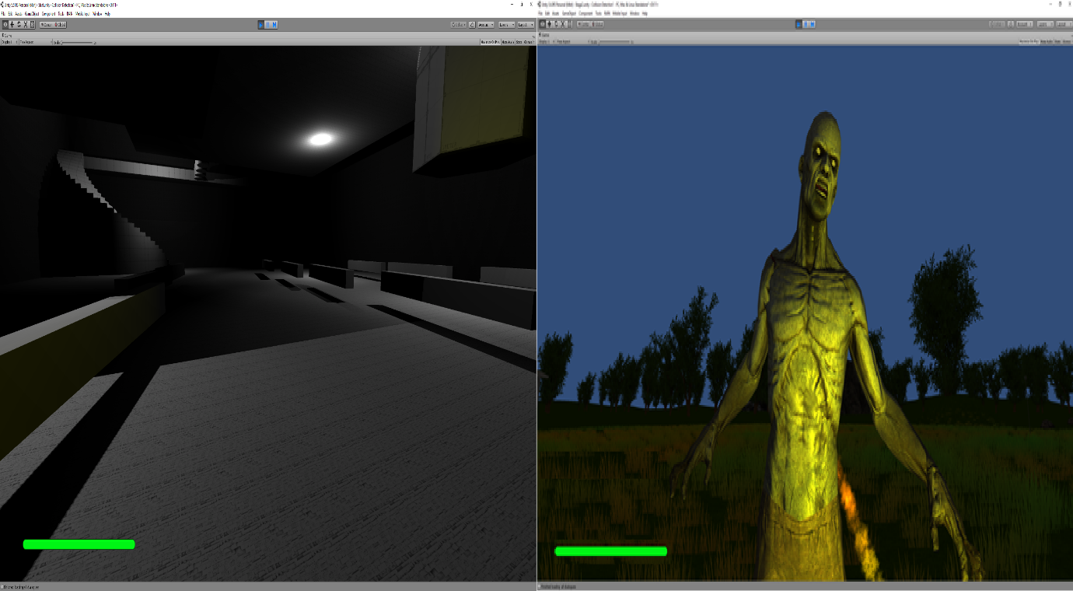

In the event a player manages to get to the end a player is greeted by an ending, it also gives the player the option to replay any of the levels again if the player desires and just like the game over screen the credits will be rolling.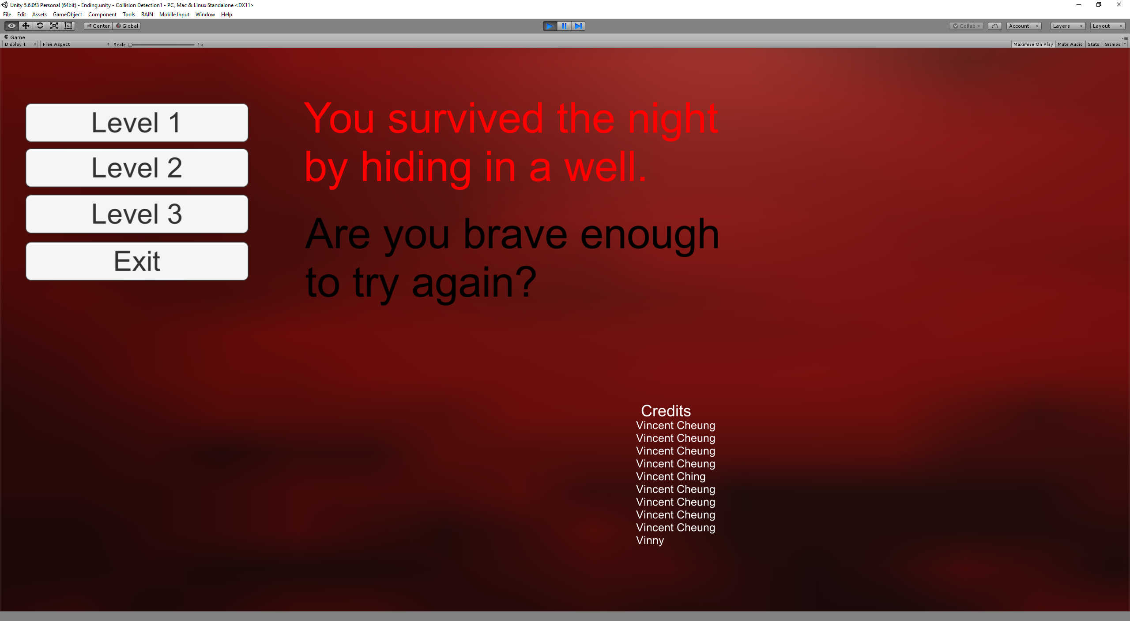

### 1.3.6 Objectives

The non-player character in the game gives the player hints on how to progress to the next level, in the first level the NPC tells the player that he should go look for the treasure which the player can find after avoiding deadly traps and getting to the end of the stage. When the player reaches the objective, in the example below the treasure, of the level text appears near the bottom of the screen, informing players that they need to press E to go to the next level. When a player does press E as informed, they’ll move on to the next level.

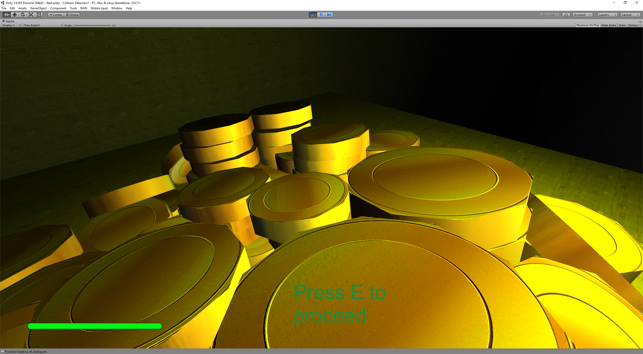

### 1.3.7 Levels and Design

In the first level the player comes face to face with the Lazy Soldier, this NPC is the player’s friend as he will inform the player what he needs to do to proceed to the next level. As the player goes to the doorway they’ll see a hole that they can drop through. This is a point of no return, if the player drops through they can’t come back and chat with the Lazy Soldier. In the first level the player is inside a building,

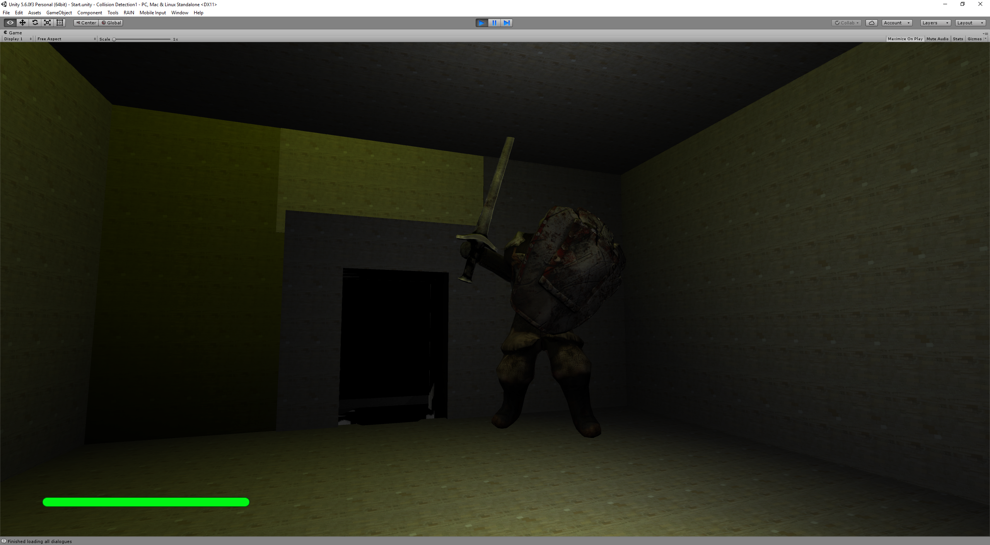

In the second level the player escapes the building with the treasure. This will be the first time the player sees daylight and there are buildings are around as well as that there are rocks, trees and foliage around. The Lazy Soldier now promoted to Shrunk Knight informs the player that he should go rest in one of those abandoned buildings.

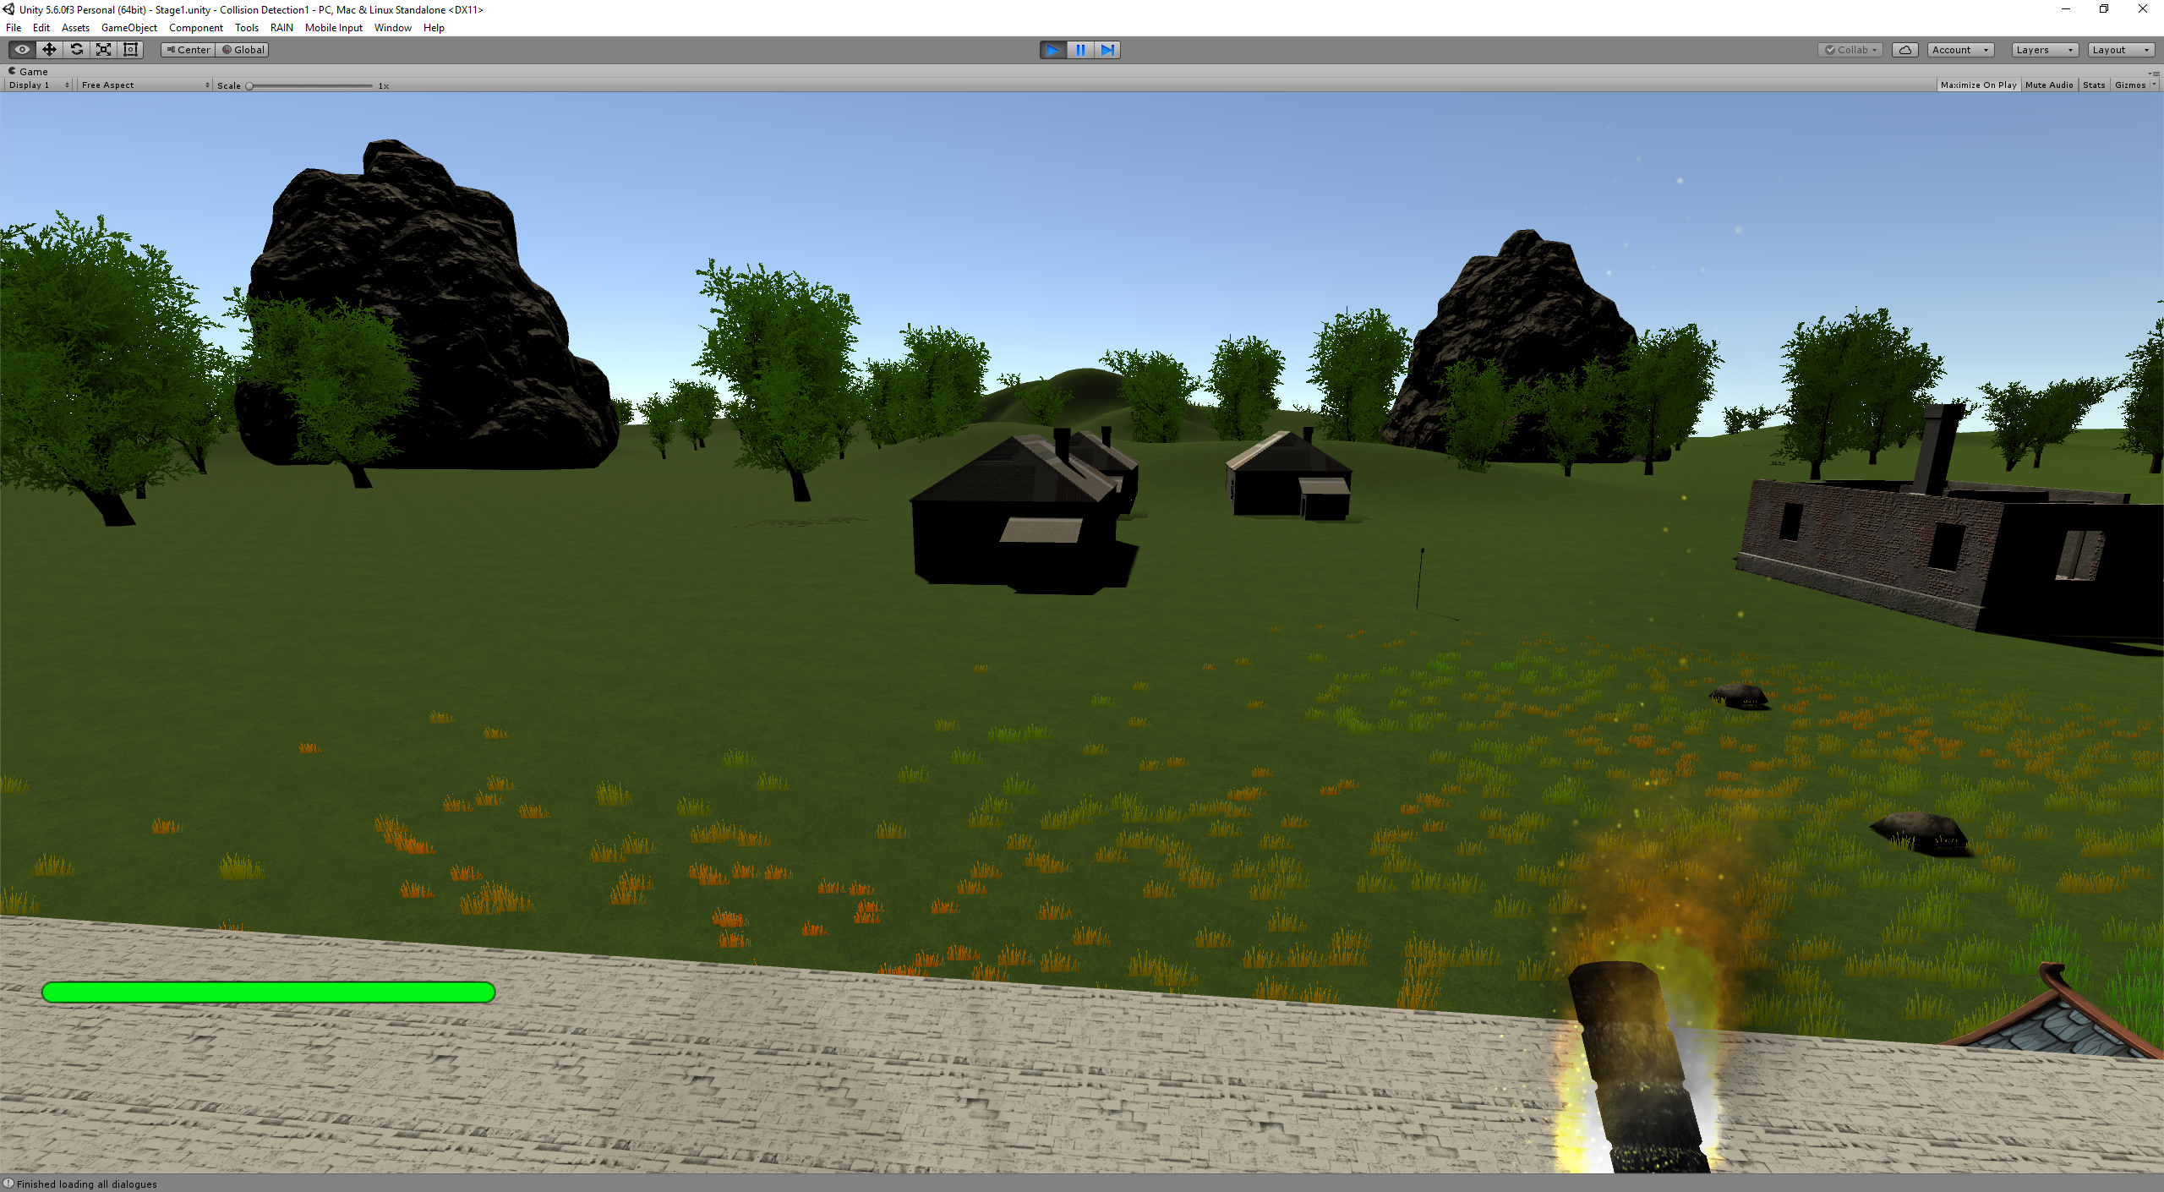

In the final level the player will wake up to find that it is night and monsters are prowling close by. The knight has also gone mad and will gives the player a vague hint of what he needs to survive the night.

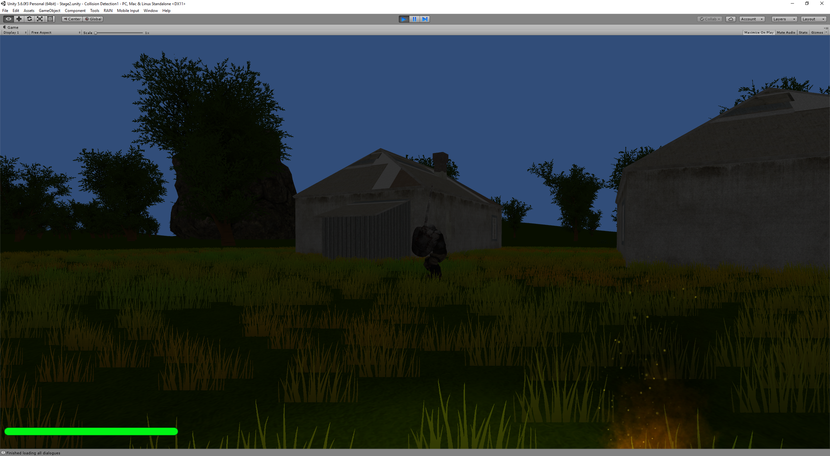

## Technology Used

The main component of the project is the Unity Game Engine, the creators of the engine are “Unity Technologies”. They describe the Unity Game engine as:

“A flexible and high-performance end-to-end development platform used to create rich interactive 2D, 3D, VR and AR experiences. Unity's powerful graphics engine and full-featured editor serve as the foundation to develop beautiful games or apps and easily bring them to multiple platforms: mobile devices, home entertainment systems, personal computers, and embedded systems.

Unity also offers solutions and services for creating games, boosting productivity, and connecting with audiences including the Unity Asset Store, Unity Cloud Build, Unity Analytics, Unity Ads, Unity Everyplay and Unity Certification.”

Another technology used in the project is the personal computer, the personal computer will be required to create and design the final year project that the student will create using the Unity Engine

## 1.4 Introducing Unity

What is Unity3D?

“Unity3D is a powerful cross-platform 3D engine and a user-friendly development environment. Easy enough for the beginner and powerful enough for the expert; Unity should interest anybody who wants to easily create 3D games and applications for mobile, desktop, the web, and consoles.” [1]

There are several reasons someone would use Unity over other game engine:

### 1.4.1 Ease of using Unity

Using Unity is quite simple but it is very powerful, you can create games for many different platforms such as PC, mobile, AR/VR and consoles. There are many popular games that have been made in Unity such as “SUPERHOT”, “Kerbal Space Program” and “Besiege” to name a few. Installing Unity is very simple and easy as well, pick the Unity edition – Personal, Plus, Pro, Enterprise, you want and then you pick your version and then just download and follow the installer, just the way you would install a normal program. Furthermore, using Unity does not require a very powerful PC, the student has run Unity that is used for development on his tablet, on a laptop and on a desktop. Although there is some minor lag on the tablet and it is a bit slow but it’s bearable, but you would want a mouse to make it easier to use, other than that, if you had the patience, you could develop a game on a tablet.

### 1.4.2 Development Costs

As mentioned in “Ease of using Unity” there are four editions of Unity for developers.

Personal, Plus, Pro and Enterprise, a chart has been provided below for the differences between each edition.



[2]

The main differences between each edition are how much content you can put in your game. If you want to make a multiplayer game you’re limited to 20 concurrent users on Personal to increase it a developer could either upgrade to Plus for 50 concurrent users, Pro for 200 concurrent users or Enterprise for a custom number of players.

Another notable thing about the differences would be how much revenue a developer can generate in each edition,

“An annual revenue capacity or funds raised capacity of $100k per fiscal year exists for Personal customers. An annual revenue capacity or funds raised capacity of $200k per fiscal year exists for Plus customers. Pro and Enterprise customers have unlimited revenue capacities.” [3]

The student used the Personal edition; the student had no intention of trying to monetise the project, therefore the most suitable edition of Unity for him was the Personal Edition as you get the base development kit and you can make a game from that. There can be zero costs involved and you can make a great game from that, but if you’re someone that is bad at designing or creating things such as characters or even animations there is the Asset Store:

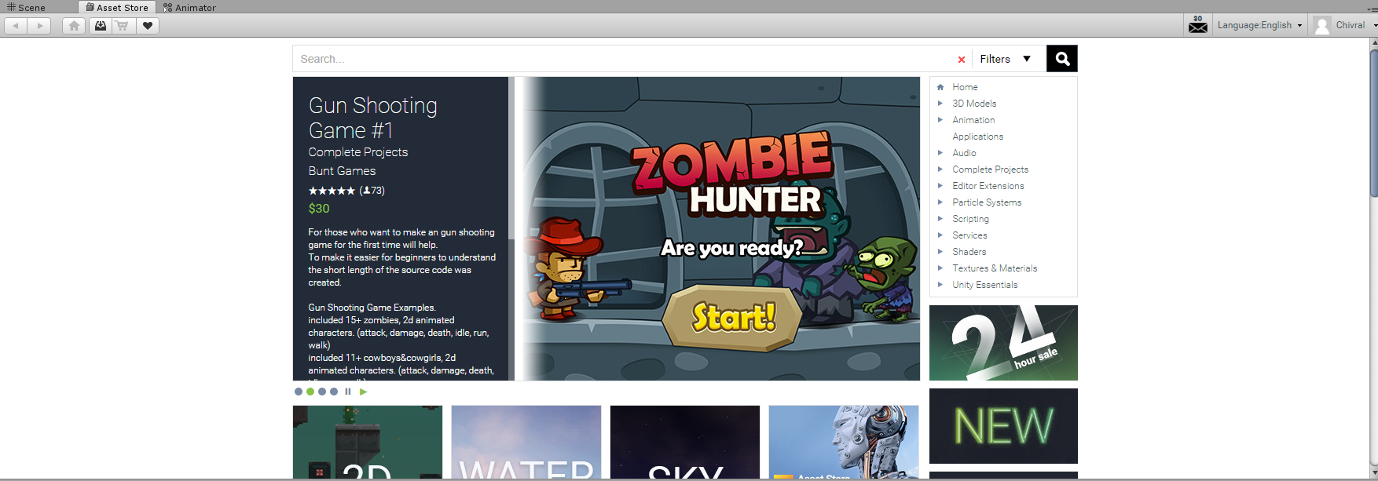

The Asset Store is very like Apple’s App Store and Google’s Google Play Store. There are “apps” in the Asset store that can make your game creating life a lot easier such as animations, textures, models, props and furniture pretty much anything for your game. There’s a catch though, most of the “good” things require money, the detailed or good assets usually have a price attached to them and the developer will need to decide if he wants to pay for these additions to his game.

### 1.4.3 Why use Unity

In the Unity game engine, there are many types of things that you can do; There’s a visual editor, you can write scripts to make your characters do things, you can basically write scripts (with a choice between JavaScript and C#) where you can make anything in your game world do whatever you want. There’s a Mecanim animation system; Mecanim is a sophisticated animation system used in Unity;” Unity’s animation system is based on the concept of Animation Clips, which contain information about how certain objects should change their position, rotation, or other properties over time.” [4]. You can create your game for multiple platforms such as consoles, desktop and mobile as well as that there’s a huge community where you can find solutions for any bugs or problems you may encounter, if there isn’t a solution you can ask in the forums. The student personally encountered a bug, submitted a bug report and got an email from Unity after a few days telling him how to solve the bug that he got.

## 1.5 Project Requirements

The project has no hardware itself but it has hardware requirements; the user must own something that can run an executable file such as a windows PC, laptop or tablet. Currently the user can’t use it on a mobile as the student didn’t add in that feature, the player would not be able to control the character

# Project Creation

The first thing the student had to at the start of the year was the project proposal, the student spent about 3 weeks trying to decide on what kind of project he wanted. After a few tips and advice from a friend the student decided to use Unity for his project. The student decided to make a game inspired by the Thief game series.

“The main tactic of *Thief* is to avoid fights and instead sneak around the enemies. *Thief* is sometimes described as either a "first-person sneaker", "sneak-em-up" or a "first-person looter”” [5]

The game the student created has most of these qualities, the game the student created wants you to avoid the enemies as they are stronger than, it gives you objectives and to get to your objectives you need to sneak past your enemies.

After the student figured out what kind of game he wanted he started to learn how to use Unity. One of the main youtubers he watched to learn Unity was Sebastian Lague [6] as he showed a lot of the basics in Unity and how to do them, as well as that Sebastian spoke clearly and explained things very well, the student followed his tutorials and learned a lot from them. After following Sebastian’s videos for a while and learning the basics the student decided to start on his project. As quite a lot of the basics were done already on a project the student decided to stay with his current project and that is why the project name ended as “Collision Detection1”. The main things the student had to learn when he watched these tutorials were understanding C#, understanding how to operate Unity and a lot of the tools Unity provides a user with. When a user first opens Unity, they are greeted with the screenshot below.

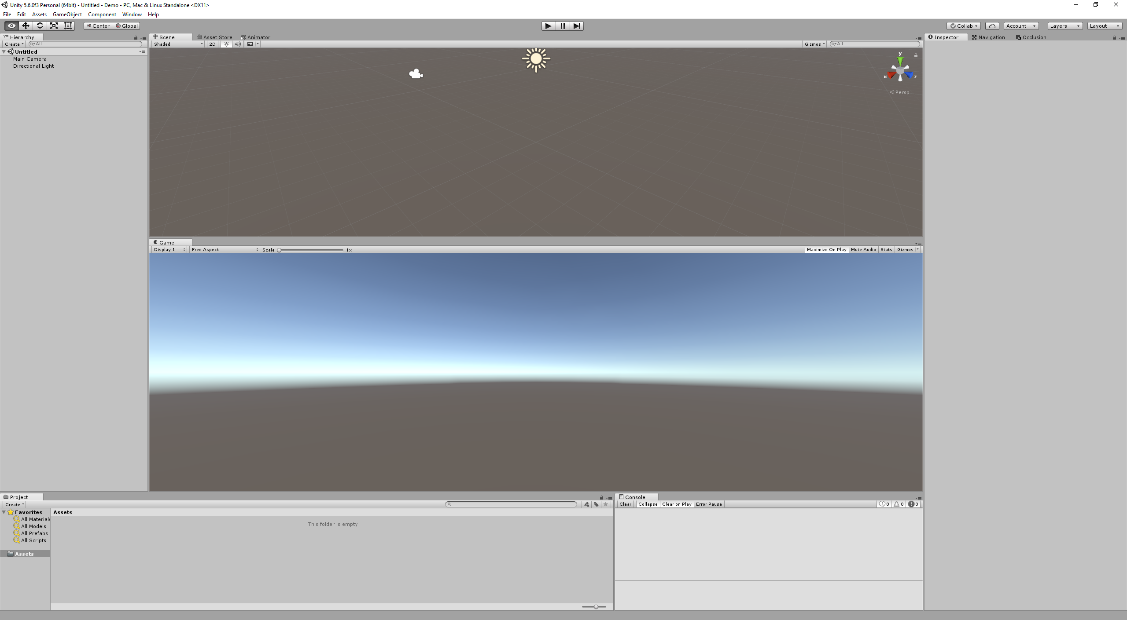

This is an empty “Scene”, the student had to figure out how to work with this scene, but only watching YouTube videos doesn’t make you a professional game developer so the student needed something more than that. That is why there’s a Unity Manual [7] the Unity Manual is basically documentation for all there is to Unity be it functions, graphics settings, working in Unity, scripting, animation, audio, UI you name it, the Unity Manual has everything you would need to get a basic game going.

After doing a lot of reading and watching YouTube videos the student had learned the basics. You could do things like create a cube, give it a scale and then you could position it wherever you want on the scene but that would only give it a standard colour of white, so you have to create materials and attach this material to the cube to give it a colour.

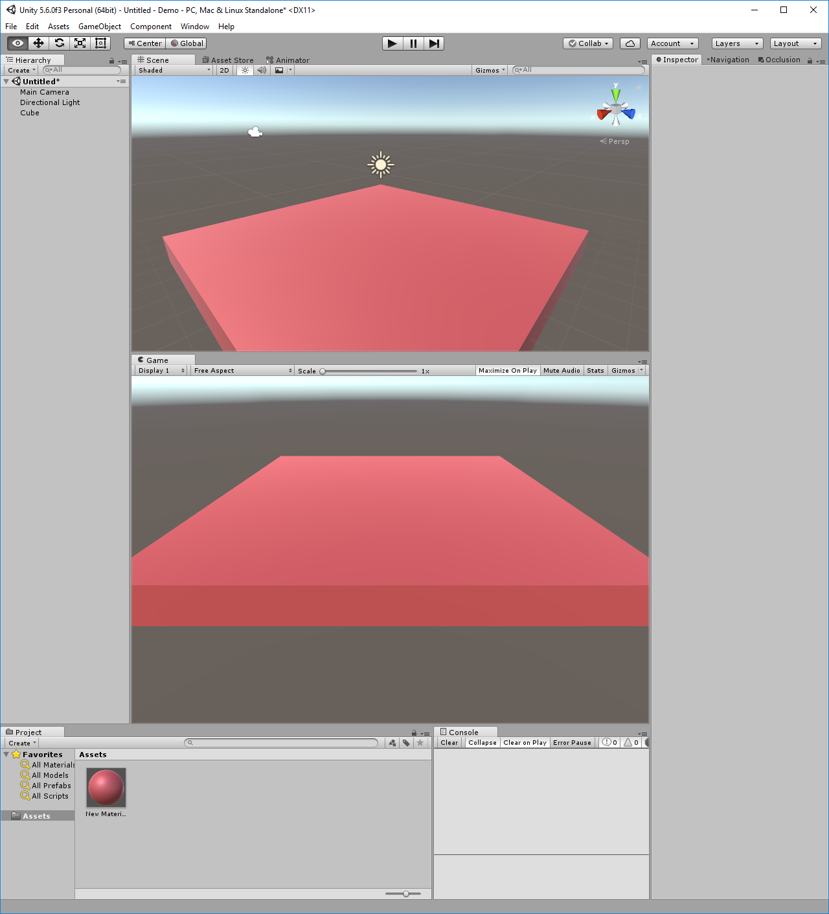

This is just the basics, to create a first-person camera you must first attach a script to a camera, this script will need to operate this camera, to allow a player to look around as well as movement. The script the student had was literally moving a camera around with WASD and making it look around with the mouse, this camera would be the player. As well as that you have to give the player a rigidbody.

“Adding a Rigidbody component to an object will put its motion under the control of Unity's physics engine. Even without adding any code, a Rigidbody object will be pulled downward by gravity and will react to collisions with incoming objects if the right [Collider](https://docs.unity3d.com/ScriptReference/Collider.html) component is also present.” [8]

The next thing the student decided to practice was to add movement to objects in Unity, this was to further improve the student’s knowledge of Unity and how to use it.

After playing around with RigidBody the student decided to figure out how to use collision detection as he noticed that things could clip through terrain and walls even though they weren’t supposed to. With RigidBody the student also got gravity.

With the Thief game in his mind the student wanted to add small collectibles in the game, this came in the form of small stationary cubes that the player could “pick up” when they walked over them, in reality the objects were destroyed when the player walks over them.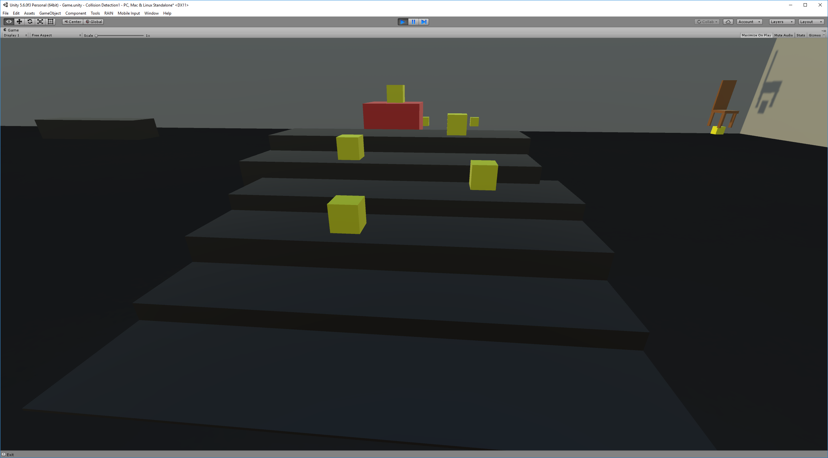

After that the student decided to develop more on his world; this came in the form of creating terrain. Terrain is more useful to create a world on rather than creating a big cube as the terrain has more functionality and you can add more things to it such as trees, foliage and grass.

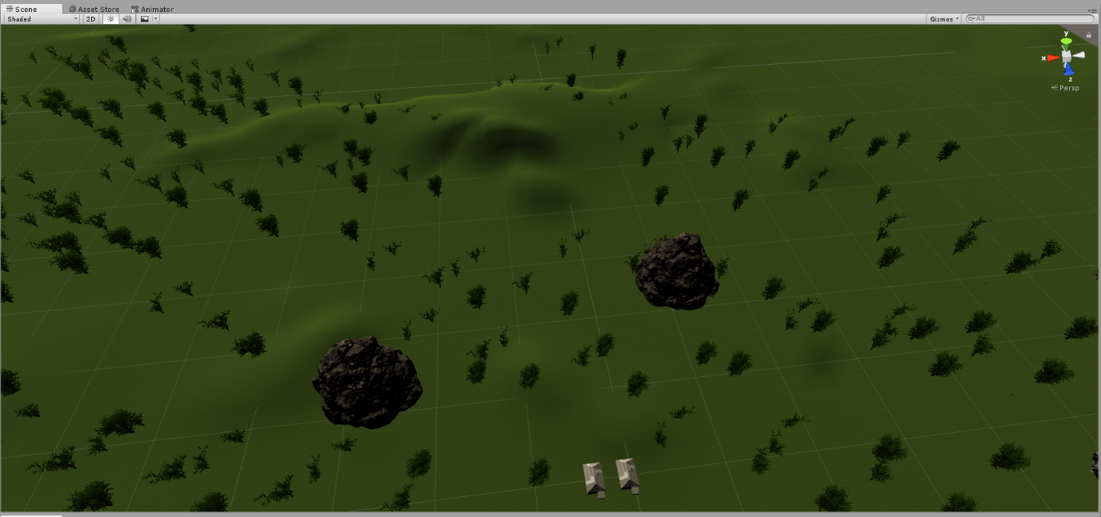

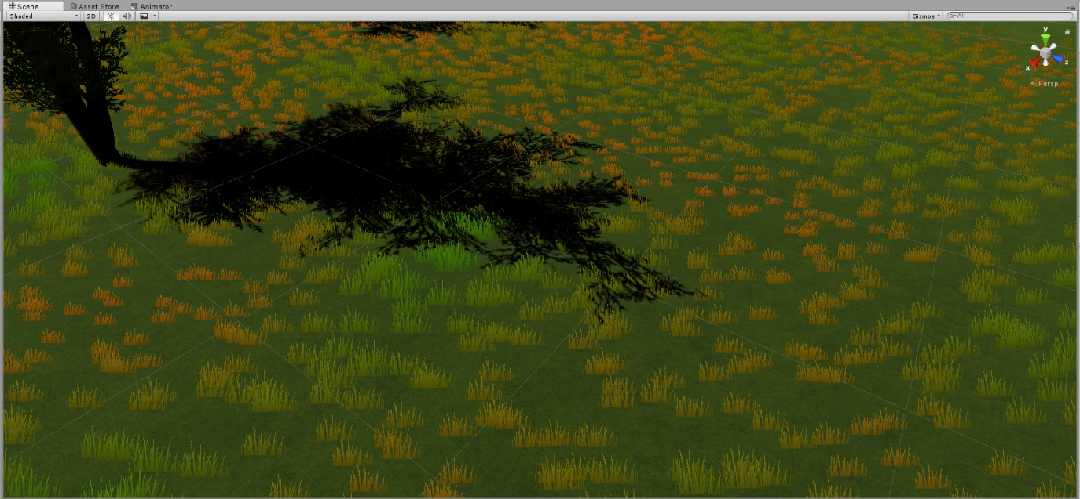

The student also used the Unity Inspector to change the terrain and create mountains and roads. The inspector tool can change the terrain but to do this you’ll want to have set up your own grass and foliage skins.

The next thing the student added was the start menu, clicking “New Game” brings the player to the very first level. 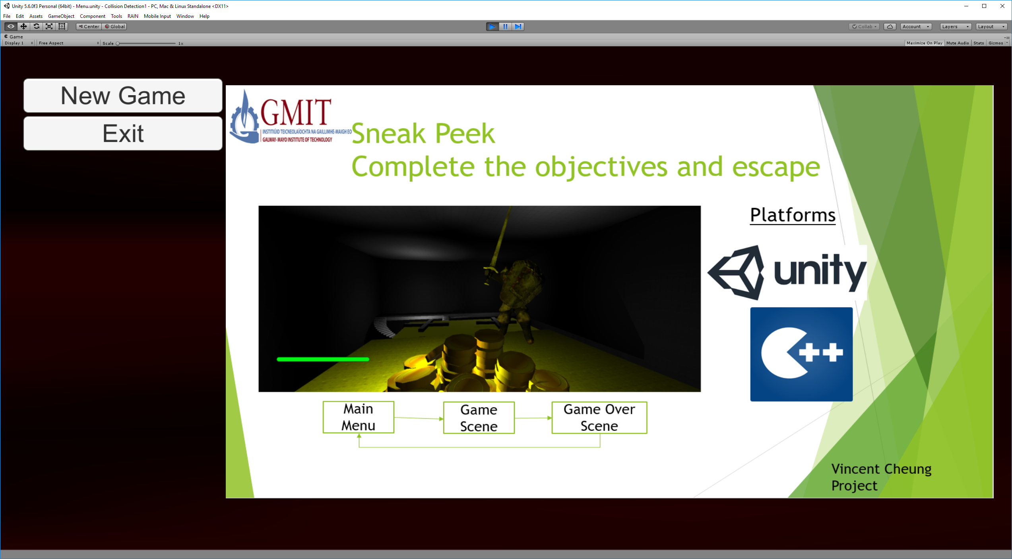

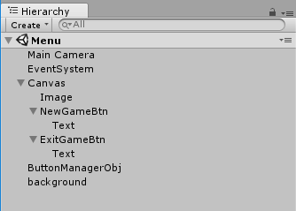To create the start menu the student had to create a canvas. This canvas contains a few items – The image, two buttons and two text elements. The image must be converted into another format so that Unity can work with it, otherwise the picture won’t show up. The two buttons also have a script attached to them to tell them what to do when someone clicks on them.

The next thing the student wanted to add was NPC dialogue. Although the student could have added the dialogue with the canvases and text the same way he added his objectives he thought it didn’t look nice enough and decided to use a tool from the Asset store. At the end, he decided on VIDE Dialogues the main reason was VIDE was free and VIDE allowed the student to have a nice-looking text box and adding in dialogue was quite complicated when compared with adding text to a canvas but the student managed. There were a few problems as like most free assets, there isn’t much documentation on how to set it up so the student had to figure it out himself.

The following thing the student did was to make his levels look better. Back then, he only had one level and it didn’t look that good in his opinion so he went and downloaded a few free assets from the store; The NatureStarterKit2 and Rocks Pack, these two assets provided the student with some simple rocks, stones and trees to make his level look better.

After that he added in objectives; to add in objectives he added in a box collider (Example will be from stage one). When the player hits the green lines (the lines make the box collider) a script is triggered, and a canvas appears with text that say: “Press E to proceed”, if the player isn’t touching the box the canvas is hidden. When the player is touching the box collider and press E when prompted the player will move on to the next level. 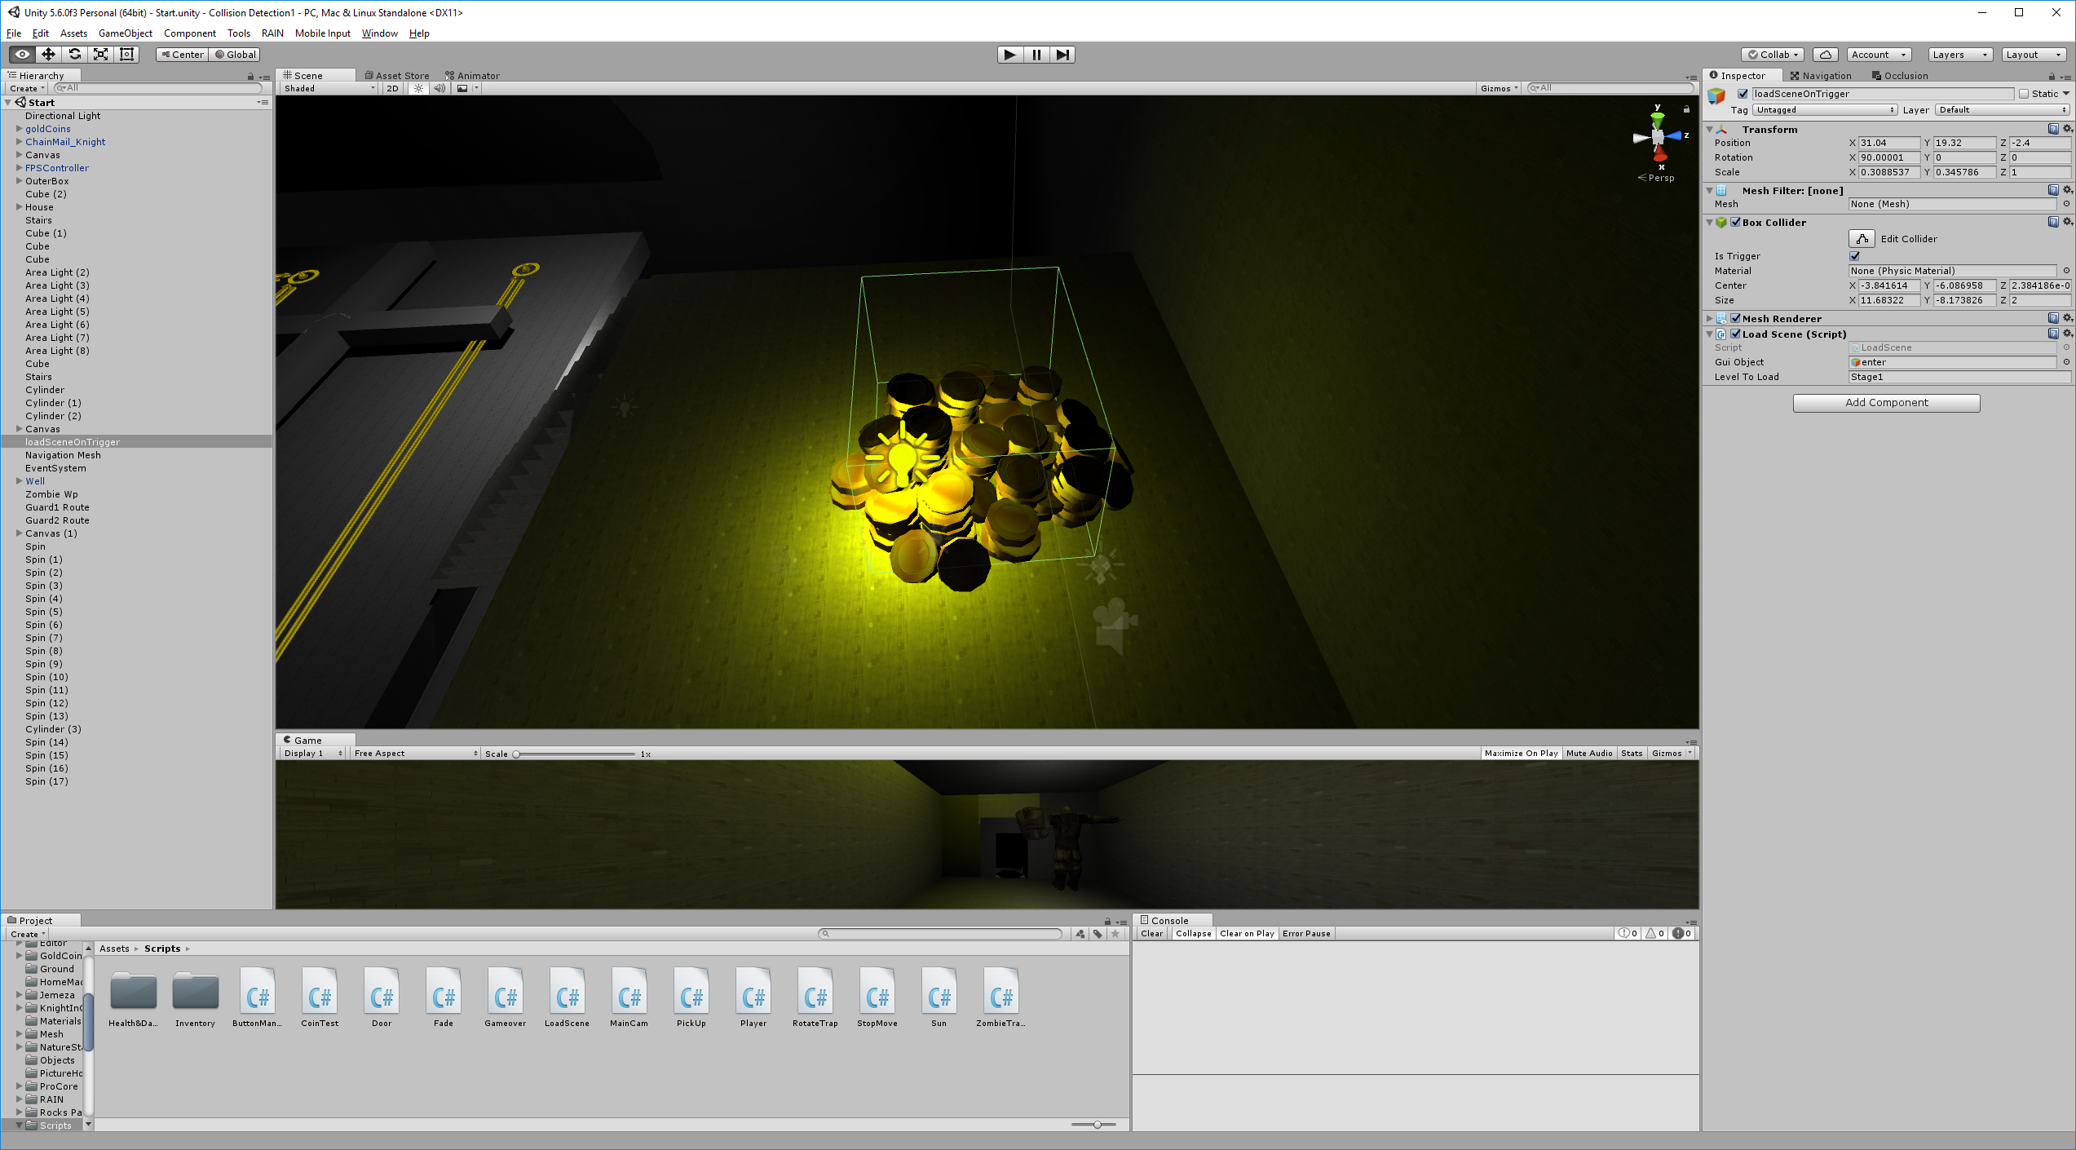

Following the objectives was the AI, after avoiding working with the AI for a while the student decided he had to add in smart AI, the student decided to use RAIN AI. After searching the internet, a while he found RAIN AI was one of the most popular free to use AI creator. The student tried RAIN AI, but the tutorials on their website was very poor so he didn’t use them he tried a few of their videos but they didn’t really explain things well so the student decided to just do it himself with the help of YouTube [9]. With the help of the video the student managed to figure out how to make the AI follow the player when they 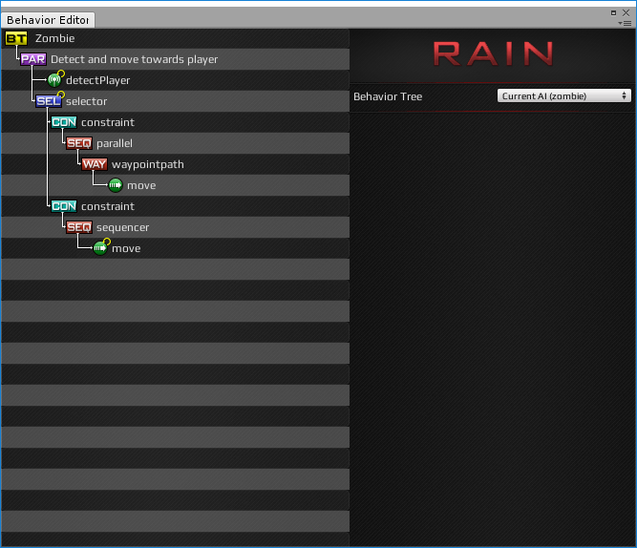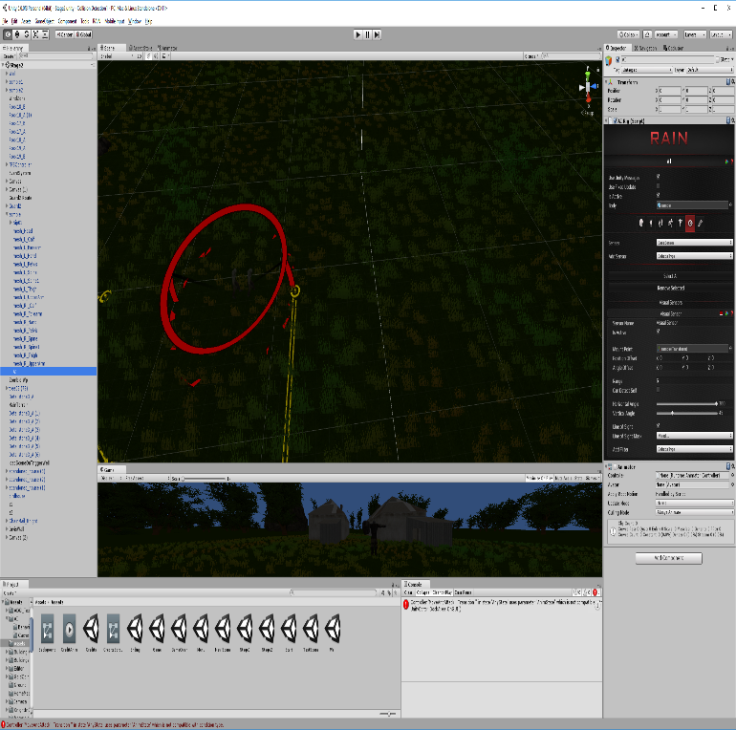entered the visual radius of the enemy which can be observed from the red circle below. As well as that the student had to set up a behaviour tree, the behavioural tree determines how the AI will act on each occasion, there is some minor scripting involved to get RAIN AI working properly as well as adding things in the IDE.

The next thing the student added was the health bar, the health bar denotes how healthy a player is and when it gets depleted the player dies. To set up the health bar the student had to set up a canvas and a slider with a script attached to the player that would change the colour of the slider depending on how much damage the player has taken. When the player’s health bar turns completely red the player dies and gets moved to another scene which is the game over scene.

After all those tasks had been completed the student decided to create more levels, the student decided to try “Pro Builder” free version from the assets store. After giving it a try for a while the student decided it was a nice tool to create interesting shapes but it just made things easier to create. E.g. to create a cube in Unity you had to right click to make the cube and then go to the inspector to change the size of it and you had to test and continue changing it until you were satisfied with how it looked. With ProBuilder the student could preview what the shape would look like before he created the shape but since the student was using the basic version there were many missing tools and shapes so the student decided to only create one level from it.

One of the final things the student had to do was to make things look better; he had capsules as his enemy and his NPC was also a cube so the student went to the asset store where he found the zombie and knight assets that were free and had animations included. The student had to create his own Animator Controllers; As well as that he added in the traps, the traps spin and if the player gets too close to them it would update the player’s health by decreasing it.

“An Animator Controller asset is created within Unity and allows you to arrange and maintain a set of animations for a character or object.” [10]

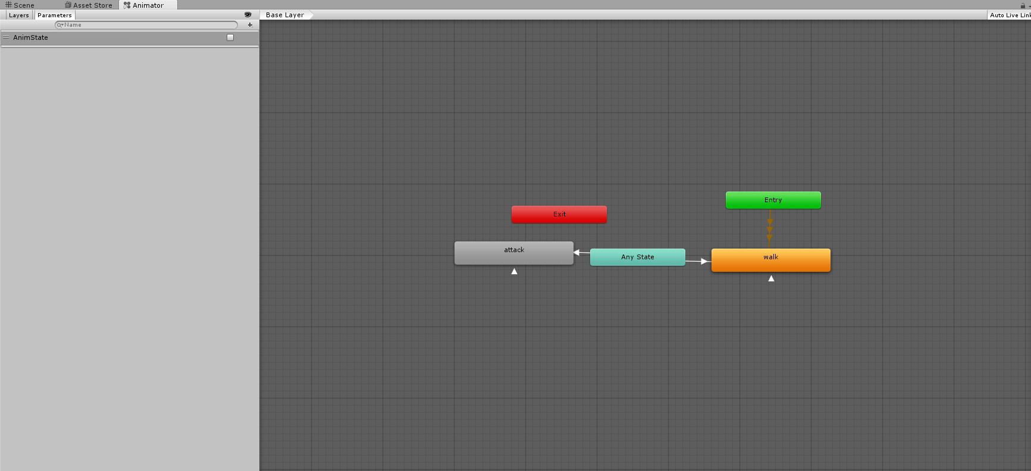

After creating the animator controller and attaching it to the enemy and NPC it will start their animations when the game has started.

The final thing the student had to do was add all the scenes to the build settings and make each scene changer swap to the right scene when they were triggered. This was a lot of work

# Problems Encountered

Throughout the year the student encountered various problems and solved them mainly himself. The problems he encountered throughout the year are listed below.

* Problems installing Unity – One of the first problems the student encountered was when he was installing Unity. At the start, he installed Unity with no problems on his desktop but when he moved to another desktop and installed an updated version of Unity it would give him a grey screen.
  + The student managed to fix this problem by installing an even newer version of Unity, he just had to wait a while until a newer version came out and he just kept on working on the old PC.
* Clipping problems, the student encountered a lot of clipping problems where objects could go through walls and or half the body of the player would be under the world and the other half above the world.
  + The student managed to fix this problem by attaching the correct colliders for the objects as well as having RigidBody on his player.
* “Mountain climbing” the player could scale the mountains by continuously spamming jump and by getting up the mountains that were acting as the barrier to stop the player falling through the map, the player could fall through the map as there is nothing to stop him after he got past the initial barrier.
  + The student added invisible walls around the map to stop a player getting past the mountains as well as that he changed the player’s settings in the FPS controller script so that he couldn’t jump up mountains by changing the possible slopes he could climb.
* RAIN AI problems, the main one was due to the bad documentation and explanations by the RAIN AI creators the student was stuck on problems. As well as that the student was stuck on a very simple problem. First it requires an explanation of how RAIN AI works. The AI require an “AI element” for them to work, this element lets them follow waypoints and find enemies. The student was stuck for a few days trying to figure out why the AI stopped chasing the player after testing the AI on different levels of the game.
  + The student fixed this issue after he found out that even the player requires an entity. The enemy couldn’t determine that the player was an entity from script alone and required a RAIN AI entity component, so he had to attach one to the player as well.
* RAIN AI problems, setting up an AI and for them to follow their own waypoints require their own Behaviour Tree.
  + The student got around this problem by making unique Behaviour Trees for each AI in the game.
* Health bar problems, the student encountered a problem when he tried to set up the health bar. The health bar would look weird and the way the health got depleted was not from the right to left but from the centre.
  + The student fixed this problem by changing the way the health bar was anchored. Rather than doing a centre anchor he did a bottom right anchor.
* VIDE Dialogue problem, due to the poor documentation there were a few requirements to get VIDE up and running which are saved dialogues made with the VIDE editor, a custom dialogue interface with a VIDE_DATA attached and a VIDE_Assign attached to the NPC that will talk player will require a script to make him able to interact with the NPC.
  + The student was unaware at the start that the player would require a script to make him able to interact with the NPC as he thought rather than the player interacting with the NPC it was the NPC interacting with the player. As well as that he didn’t know that after attaching the script you had to set up a UIManager so that you can see the dialogue and dialogue box.
* Animations problems; the animations would not “play” correctly or the character would just glide across the floor.
  + The student didn’t set up his animation controllers up properly, after setting them up properly the animations would play.
* Trap problems, when the student tried to make a star trap and make one prong the parent and the other prongs as a child of that they would all change size.
  + This problem was solved by not making the anything a child of each other.
* Unity porting project from one version to another. The student did development on both his laptop and desktop. His desktop used an older version of Unity while his laptop was using a newer version of Unity. After developing on his laptop and then he zipped and brought it over to his desktop Unity would continuously crash and refuse to open the project. The student was given an option to submit a bug so he did, the bug report asked things like “What happened and how you would replicate the problem” another thing was it asked for an email which the student filled in as well. After a few days, he got an email from Unity themselves with a solution
  + The student therefore decided to follow the advice from the email and updated the desktop version of Unity and the new Unity could open the project with no problems.

“Hi,  
  
The crash you are experiencing happens when opening a Unity project made with an incompatible version. Now if the version that the project is created with is OLDER than the one you are using to open it with, deleting the "Library" folder in the project directory should resolve the crash.  
If you are using an older version than the last used to open the project, however, this is not supported, as Unity is not forward-compatible.  
  
I hope this clears things up for you.  
  
Best regards,  
Paulina  
QA Team”

* The student encountered a Unity bug during the last few days where he was trying to build his project into an executable. When the project was being built it would be stuck on 5/11 clustering the student thought it was a problem on his end so ended up not looking on the internet for a solution right at the start. He had the project on his laptop and he at the start left it on overnight building the project but the project would still not finish building, so he thought it might be because the laptop wasn’t that powerful so he brought the project to his desktop. That is when the student encountered the previous problem, where there were incompatibilities. After solving that problem, the student ported the project to the desktop and tried to build it but it still wouldn’t build. This was when the student decided to search on for a solution.
  + It is a solution to a temporary problem but it doesn’t fix the problem as the solution simply avoids the auto-baking in Unity but it did let the student build the project in about a minute rather than spending more than 10 hours and the project still not being built.

Colsone

“Ive found the problem, go to the lighting window. Then scroll all the way down to other settings. Then you will see a box that says auto, uncheck it. “[12]

# Scripts

## ZombieTransition.cs

The ZombieTransition script changes the animation of idle walking to attack animation for the zombie.

using UnityEngine;

using System.Collections;

public class ZombieTransition : MonoBehaviour {

public float speed = 10f;

public Vector3 maxVelocity = new Vector3(3, 5);

public GameObject Zombie;

public Animator zombieAnim;

public GameObject Player;

public float damage = .1f;

public bool moveattack;

void Awake()

{

zombieAnim = Zombie.GetComponent<Animator>();

}

// Use this for initialization

void Start () {

}

// Update is called once per frame

void Update()

{

}

void OnTriggerStay(Collider other)

{

zombieAnim.SetBool("AnimState", false);

GetComponent<Animation>().Play();

zombieAnim.setFloat("Speed", Speed);

print("Attack");

other.gameObject.GetComponent<CharacterHealth>().TakeDamage(damage);

}

}

## Sun.cs

The Sun.cs rotates the sun and moon, imagine the sun is at 12 o’clock and the moon is at 6, the rotation speed is determined by the 10f and the sun rotates towards 6 and at the same time the moon rotates towards 12 this cycle is repeated. By playing with the 10f you can have long nights / short days or vice versa.

using UnityEngine;

using System.Collections;

public class Sun : MonoBehaviour {

// Use this for initialization

void Start () {

}

// Update is called once per frame

void Update () {

transform.RotateAround(Vector3.zero, Vector3.right, 10f * Time.deltaTime);

transform.LookAt(Vector3.zero);

}

}

## StopMove.cs

The StopMove.cs is a script that is required for the player to be able to interact with VIDE, this script also allows a player to interact with NPCs which have the VIDE dialogue attached to them

using UnityEngine;

using System.Collections;

public class StopMove : MonoBehaviour

{

//This script handles player movement and interaction with other NPC game objects

//Reference to our diagUI script for quick access

public exampleUI diagUI;

void Start()

{

Cursor.visible = false;

Cursor.lockState = CursorLockMode.Locked;

}

void Update()

{

//Only allow player to move and turn if there are no dialogs loaded

if (!VIDE_Data.isLoaded)

{

//transform.Rotate(0, Input.GetAxis("Mouse X") * 5, 0);

// float move = Input.GetAxisRaw("Vertical");

// transform.position += transform.forward * 5 * move * Time.deltaTime;

}

//Interact with NPCs when hitting spacebar

if (Input.GetKeyDown(KeyCode.E))

{

TryInteract();

}

//Hide/Show cursor

if (Input.GetMouseButtonDown(0))

{

Cursor.visible = !Cursor.visible;

if (Cursor.visible)

Cursor.lockState = CursorLockMode.None;

else

Cursor.lockState = CursorLockMode.Locked;

}

}

//Casts a ray to see if we hit an NPC and, if so, we interact

void TryInteract()

{

RaycastHit rHit;

if (Physics.Raycast(transform.position, transform.forward, out rHit, 2))

{

//In this example, we will try to interact with any collider the raycast finds

//Lets grab the NPC's DialogueAssign script... if there's any

VIDE_Assign assigned;

if (rHit.collider.GetComponent<VIDE_Assign>() != null)

assigned = rHit.collider.GetComponent<VIDE_Assign>();

else return;

if (!VIDE_Data.inScene)

{

Debug.LogError("No VIDE_Data component in scene!");

return;

}

if (!VIDE_Data.isLoaded)

{

//... and use it to begin the conversation

diagUI.Begin(assigned);

}

else

{

//If conversation already began, let's just progress through it

diagUI.CallNext();

}

}

}

}

## RotateTrap.cs

The RotateTrap.cs is the script that is attached to the object that becomes the traps.

using UnityEngine;

using System.Collections;

public class RotateTrap : MonoBehaviour {

float speed = 200f;

public float damage = 5f;

// Use this for initialization

void Start () {

}

// Update is called once per frame

void Update () {

transform.Rotate(Vector3.up * Time.deltaTime * speed);

}

void OnTriggerEnter(Collider other) {

other.gameObject.GetComponent<CharacterHealth>().TakeDamage(damage);

}

}

## Player.cs

The Player.cs script when attached to the player will allow them to pick up the coins on the ground, when the player touches the coin the coin gets destroyed.

using UnityEngine;

using System.Collections;

public class Player : MonoBehaviour {

public float speed = 6;

Vector3 velocity;

int coinCount;

Rigidbody myRigidBody;

// Use this for initialization

void Start () {

myRigidBody = GetComponent<Rigidbody>();

}

// Update is called once per frame

void Update () {

Vector3 input = new Vector3 ( Input.GetAxisRaw("Horizontal"), 0, Input.GetAxisRaw("Vertical") );

Vector3 direction = input.normalized;

velocity = direction * speed;

}

void FixedUpdate() {

myRigidBody.position += velocity * Time.fixedDeltaTime;

}

void OnTriggerEnter(Collider triggerCollider)

{

if (triggerCollider.tag == "Coin")

{

Destroy(triggerCollider.gameObject);

}

}

}

## Pickup.cs

The Pickup.cs was a script that lets the player pick up anything in the world (including terrain) This was used for testing purposes and was not included in the final version of the game

using UnityEngine;

using System.Collections;

public class PickUp : MonoBehaviour {

GameObject grabbedObject;

float grabbedObjectSize;

// Use this for initialization

void Start () {

}

GameObject GetMouseHoverObject(float range) {

Vector3 position = gameObject.transform.position;

RaycastHit raycastHit;

Vector3 target = position + Camera.main.transform.forward * range;

if (Physics.Linecast(position, target,out raycastHit))

return raycastHit.collider.gameObject;

return null;

}

void TryGrabObject(GameObject grabObject)

{

if (grabObject == null)

return;

grabbedObject = grabObject;

//GetComponent.< Renderer > ().bounds.size;

}

void DropObject()

{

if (grabbedObject == null)

return;

grabbedObject = null;

}

// Update is called once per frame

void Update () {

if (Input.GetMouseButtonDown(1))

{

if (grabbedObject == null)

TryGrabObject(GetMouseHoverObject(5));

else

DropObject();

}

if(grabbedObject!=null)

{

Vector3 newPosition = gameObject.transform.position + Camera.main.transform.forward * 5;

grabbedObject.transform.position = newPosition;

}

}

}

## LoadScene.cs

The LoadScene.cs is the trigger that pops up the canvas and allows the player to press E to move to the next stage

using UnityEngine;

using System.Collections;

public class LoadScene : MonoBehaviour {

public GameObject guiObject;

public string levelToLoad;

// Use this for initialization

void Start () {

guiObject.SetActive(false);

}

void OnTriggerStay(Collider other)

{

if(other.gameObject.tag=="Player")

{

guiObject.SetActive(true);

if(guiObject.activeInHierarchy == true && Input.GetButtonDown("Use"))//If triggered guiObject is true

{

Application.LoadLevel(levelToLoad);

}

// SceneManager.LoadScene("TestScene");

}

}

void OnTriggerExit()

{

guiObject.SetActive(false);

}

}

## Fade.cs

The Fade.cs script changes the alpha scale of the screen (makes it white), this script was supposed to be the transition from scene to scene but was scrapped. This is

using UnityEngine;

using UnityEngine.UI;

using System.Collections;

public class Fade : MonoBehaviour {

public static Fade Instance{ set; get;}

public Image fadeImage;

private bool isInTransition;

private float transition;

private bool isShowing;

private float duration;

private void Awake()

{

Instance = this;

//DontDestroyOnLoad(transform.gameObject);

}

public void Fader(bool showing, float duration)

{

isShowing = showing;

isInTransition = true;

this.duration = duration;

transition = (isShowing) ? 0 : 1;

}

private void Update()

{

if (Input.GetKeyDown(KeyCode.X))

Fader(true, 1.25f);

if (!isInTransition)

return;

transition += (isShowing) ? Time.deltaTime * (1 / duration) : -Time.deltaTime * (1 / duration);

fadeImage.color = Color.Lerp(new Color(1, 1, 1, 0), Color.white, transition);

if (transition > 1 || transition < 0)

isInTransition = false;

}

}

## FirstPersonController.cs

This is a provided as a standard asset by Unity. When this script is attached to a player it allows them to do things such as movement and looking around, jumping

using System;

using UnityEngine;

using UnityStandardAssets.CrossPlatformInput;

using UnityStandardAssets.Utility;

using Random = UnityEngine.Random;

namespace UnityStandardAssets.Characters.FirstPerson

{

[RequireComponent(typeof (CharacterController))]

[RequireComponent(typeof (AudioSource))]

public class FirstPersonController : MonoBehaviour

{

[SerializeField] private bool m_IsWalking;

[SerializeField] private float m_WalkSpeed;

[SerializeField] private float m_RunSpeed;

[SerializeField] [Range(0f, 1f)] private float m_RunstepLenghten;

[SerializeField] private float m_JumpSpeed;

[SerializeField] private float m_StickToGroundForce;

[SerializeField] private float m_GravityMultiplier;

[SerializeField] private MouseLook m_MouseLook;

[SerializeField] private bool m_UseFovKick;

[SerializeField] private FOVKick m_FovKick = new FOVKick();

[SerializeField] private bool m_UseHeadBob;

[SerializeField] private CurveControlledBob m_HeadBob = new CurveControlledBob();

[SerializeField] private LerpControlledBob m_JumpBob = new LerpControlledBob();

[SerializeField] private float m_StepInterval;

[SerializeField] private AudioClip[] m_FootstepSounds; // an array of footstep sounds that will be randomly selected from.

[SerializeField] private AudioClip m_JumpSound; // the sound played when character leaves the ground.

[SerializeField] private AudioClip m_LandSound; // the sound played when character touches back on ground.

private Camera m_Camera;

private bool m_Jump;

private float m_YRotation;

private Vector2 m_Input;

private Vector3 m_MoveDir = Vector3.zero;

private CharacterController m_CharacterController;

private CollisionFlags m_CollisionFlags;

private bool m_PreviouslyGrounded;

private Vector3 m_OriginalCameraPosition;

private float m_StepCycle;

private float m_NextStep;

private bool m_Jumping;

private AudioSource m_AudioSource;

// Use this for initialization

private void Start()

{

m_CharacterController = GetComponent<CharacterController>();

m_Camera = Camera.main;

m_OriginalCameraPosition = m_Camera.transform.localPosition;

m_FovKick.Setup(m_Camera);

m_HeadBob.Setup(m_Camera, m_StepInterval);

m_StepCycle = 0f;

m_NextStep = m_StepCycle/2f;

m_Jumping = false;

m_AudioSource = GetComponent<AudioSource>();

m_MouseLook.Init(transform , m_Camera.transform);

}

// Update is called once per frame

private void Update()

{

RotateView();

// the jump state needs to read here to make sure it is not missed

if (!m_Jump)

{

m_Jump = CrossPlatformInputManager.GetButtonDown("Jump");

}

if (!m_PreviouslyGrounded && m_CharacterController.isGrounded)

{

StartCoroutine(m_JumpBob.DoBobCycle());

PlayLandingSound();

m_MoveDir.y = 0f;

m_Jumping = false;

}

if (!m_CharacterController.isGrounded && !m_Jumping && m_PreviouslyGrounded)

{

m_MoveDir.y = 0f;

}

m_PreviouslyGrounded = m_CharacterController.isGrounded;

}

private void PlayLandingSound()

{

m_AudioSource.clip = m_LandSound;

m_AudioSource.Play();

m_NextStep = m_StepCycle + .5f;

}

private void FixedUpdate()

{

float speed;

GetInput(out speed);

// always move along the camera forward as it is the direction that it being aimed at

Vector3 desiredMove = transform.forward*m_Input.y + transform.right*m_Input.x;

// get a normal for the surface that is being touched to move along it

RaycastHit hitInfo;

Physics.SphereCast(transform.position, m_CharacterController.radius, Vector3.down, out hitInfo,

m_CharacterController.height/2f, Physics.AllLayers, QueryTriggerInteraction.Ignore);

desiredMove = Vector3.ProjectOnPlane(desiredMove, hitInfo.normal).normalized;

m_MoveDir.x = desiredMove.x*speed;

m_MoveDir.z = desiredMove.z*speed;

if (m_CharacterController.isGrounded)

{

m_MoveDir.y = -m_StickToGroundForce;

if (m_Jump)

{

m_MoveDir.y = m_JumpSpeed;

PlayJumpSound();

m_Jump = false;

m_Jumping = true;

}

}

else

{

m_MoveDir += Physics.gravity*m_GravityMultiplier*Time.fixedDeltaTime;

}

m_CollisionFlags = m_CharacterController.Move(m_MoveDir*Time.fixedDeltaTime);

ProgressStepCycle(speed);

UpdateCameraPosition(speed);

m_MouseLook.UpdateCursorLock();

}

private void PlayJumpSound()

{

m_AudioSource.clip = m_JumpSound;

m_AudioSource.Play();

}

private void ProgressStepCycle(float speed)

{

if (m_CharacterController.velocity.sqrMagnitude > 0 && (m_Input.x != 0 || m_Input.y != 0))

{

m_StepCycle += (m_CharacterController.velocity.magnitude + (speed*(m_IsWalking ? 1f : m_RunstepLenghten)))*

Time.fixedDeltaTime;

}

if (!(m_StepCycle > m_NextStep))

{

return;

}

m_NextStep = m_StepCycle + m_StepInterval;

PlayFootStepAudio();

}

private void PlayFootStepAudio()

{

if (!m_CharacterController.isGrounded)

{

return;

}

// pick & play a random footstep sound from the array,

// excluding sound at index 0

int n = Random.Range(1, m_FootstepSounds.Length);

m_AudioSource.clip = m_FootstepSounds[n];

m_AudioSource.PlayOneShot(m_AudioSource.clip);

// move picked sound to index 0 so it's not picked next time

m_FootstepSounds[n] = m_FootstepSounds[0];

m_FootstepSounds[0] = m_AudioSource.clip;

}

private void UpdateCameraPosition(float speed)

{

Vector3 newCameraPosition;

if (!m_UseHeadBob)

{

return;

}

if (m_CharacterController.velocity.magnitude > 0 && m_CharacterController.isGrounded)

{

m_Camera.transform.localPosition =

m_HeadBob.DoHeadBob(m_CharacterController.velocity.magnitude +

(speed*(m_IsWalking ? 1f : m_RunstepLenghten)));

newCameraPosition = m_Camera.transform.localPosition;

newCameraPosition.y = m_Camera.transform.localPosition.y - m_JumpBob.Offset();

}

else

{

newCameraPosition = m_Camera.transform.localPosition;

newCameraPosition.y = m_OriginalCameraPosition.y - m_JumpBob.Offset();

}

m_Camera.transform.localPosition = newCameraPosition;

}

private void GetInput(out float speed)

{

// Read input

float horizontal = CrossPlatformInputManager.GetAxis("Horizontal");

float vertical = CrossPlatformInputManager.GetAxis("Vertical");

bool waswalking = m_IsWalking;

#if !MOBILE_INPUT

// On standalone builds, walk/run speed is modified by a key press.

// keep track of whether or not the character is walking or running

m_IsWalking = !Input.GetKey(KeyCode.LeftShift);

#endif

// set the desired speed to be walking or running

speed = m_IsWalking ? m_WalkSpeed : m_RunSpeed;

m_Input = new Vector2(horizontal, vertical);

// normalize input if it exceeds 1 in combined length:

if (m_Input.sqrMagnitude > 1)

{

m_Input.Normalize();

}

// handle speed change to give an fov kick

// only if the player is going to a run, is running and the fovkick is to be used

if (m_IsWalking != waswalking && m_UseFovKick && m_CharacterController.velocity.sqrMagnitude > 0)

{

StopAllCoroutines();

StartCoroutine(!m_IsWalking ? m_FovKick.FOVKickUp() : m_FovKick.FOVKickDown());

}

}

private void RotateView()

{

m_MouseLook.LookRotation (transform, m_Camera.transform);

}

private void OnControllerColliderHit(ControllerColliderHit hit)

{

Rigidbody body = hit.collider.attachedRigidbody;

//dont move the rigidbody if the character is on top of it

if (m_CollisionFlags == CollisionFlags.Below)

{

return;

}

if (body == null || body.isKinematic)

{

return;

}

body.AddForceAtPosition(m_CharacterController.velocity*0.1f, hit.point, ForceMode.Impulse);

}

}

}

## ButtonManager.cs

The ButtonManager.cs is the script that is attached to the Exit button and New game buttons only, this script will let them start a new game or exit game

using UnityEngine;

using System.Collections;

using UnityEngine.SceneManagement;

public class ButtonManager : MonoBehaviour {

public void NewGameBtn(string newGameLevel)

{

SceneManager.LoadScene(newGameLevel);

}

public void ExitGameBtn()

{

Application.Quit();

}

}

## CharacterHealth.cs

CharacterHealth.cs is the script that sets and gets the player health. When Die() is called the player is dead and the game over screen is called. DealDamage() is the damage dealt to the player and when that hits 0 is when Die() is called

using UnityEngine;

using System.Collections;

using UnityEngine.UI;

public class CharacterHealth : MonoBehaviour {

public float CurrentHealth { get; set;}

public float MaxHealth { get; set;}

public bool alive = true;

public Slider healthbar;

public string levelToLoad;

// Use this for initialization

void Start () {

MaxHealth = 20f;

//Reset health to full on game load/reload

CurrentHealth = MaxHealth;

healthbar.value = CalcHealth();

}

// Update is called once per frame

void Update () {

if (Input.GetKeyDown(KeyCode.X))

DealDamage(6);

}

void DealDamage(float damageValue)

{

//Test function, damage player's health

CurrentHealth -= damageValue;

healthbar.value = CalcHealth();

//If player runs out of health kill player

if (CurrentHealth <= 0)

Die();

}

public void TakeDamage(float damage)

{

CurrentHealth -= damage;

healthbar.value = CalcHealth();

if (CurrentHealth <= 0)

Die();

}

float CalcHealth()

{

return CurrentHealth / MaxHealth;

}

void Die() {

CurrentHealth = 0;

Debug.Log("You Died");

Destroy(gameObject);

Application.LoadLevel(levelToLoad);

}

}

# Architecture Diagram

The architecture diagram shows the design of the system and how it works

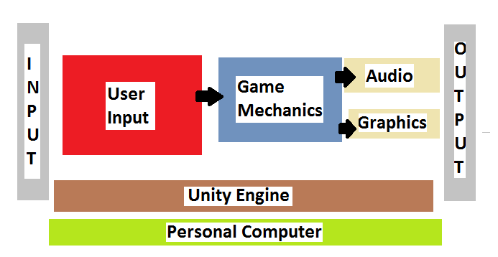

# Conclusion

Overall the project was a success, the student managed to implement the mechanics that he wanted for his game such as the AI; when they see the player, they’d start chasing the player until the player manages to outrun it a certain distance. A waypoint route that the AI follow, this was to simulate patrolling for the AI. An NPC the player could talk to with dialogue and dialogue choices where each choice leads to different answers the main point of the NPC is to give guidance to the player so that the player can complete his objectives. As well as that there is a menu, where the player can choose what levels to play or exit the game; the option to choose what level to play only appears when a player has died at least once. The student also designed his own levels, it has foliage and rocks to make a more natural look as well as houses that a player can enter. There are several hazards on the map as well such as powerful enemies and spinning traps that can wound and kill the player.

As well as that the student managed to find out just how hard it was to make a game himself from scratch and that there aren’t simple fixes to some bugs, such as bugs that are part of Unity which he encountered when he tried to build the project. He didn’t expect things would be as complicated as it was, such as designing the map and levels and implementing “smart” AI that worked, since it was quite simple to make AI that weren’t smart but to make AI that were intelligent and would do certain tasks was a lot harder.

Furthermore, the student encountered a few bugs, but with the big community behind Unity the student managed to solve them. The student also encountered a bug where his Unity would keep on crashing and there was an option to submit a bug report, the student did and after a few days someone from Unity sent him an email detailing the reasons of why it is happening and how to solve the problem.

In conclusion, the student was satisfied with the experience he gained from using Unity it taught him a lot of new things such as motivation for a big project, as well as that the student learned more about game development and the difficulties there are when developing a game on your own with only guides online.

# References

[1] code.tutsplus.com, Ian Zamojc, 17 May 2012, “Introduction to Unity”, [Online]. Available:

<https://code.tutsplus.com/tutorials/introduction-to-unity3d--mobile-10752>

[2] Unity3D, 2017, “Development cost”, [Online]. Available:

<https://store.unity.com/>

[3] Unity3D, 2017, “Development cost”, [Online]. Available:

<https://store.unity.com/>

[4] Unity3D, 2017, “Why use Unity”, [Online], Available:

<https://docs.unity3d.com/Manual/AnimationOverview.html>

[5] Wikipedia, 31 March 2017, “Project Creation”, [Online], Available:

<https://en.wikipedia.org/wiki/Thief_(series)>

[6] Sebastian Lague, 2017, “Project Creation”, [Online], Available:

<https://www.youtube.com/channel/UCmtyQOKKmrMVaKuRXz02jbQ>

[7] Unity3D, 2017, “Project Creation”, [Online], Available:

<https://docs.unity3d.com/Manual/UnityManual.html>

[8] Unity3D, 2017, “Project Creation”, [Online], Available:

<https://docs.unity3d.com/ScriptReference/Rigidbody.html>

[9] Ibrahim Mahmoud, 2017, “Project Creation”, [Online], Available:

<https://www.youtube.com/watch?v=YItZIz5rKTg>

[10] Unity3D, 2017, “Project Creation”, [Online], Available:

<https://docs.unity3d.com/Manual/class-AnimatorController.html>

[11] answers.unity3d.com, Colsone, Nov 22 2015, “Problems Encountered”, [Online], Available:

<http://answers.unity3d.com/questions/1034587/511-clustering.html>

# Unity Store Assets and Libraries Used

## Assets

VIDE Dialogues

Scripting/AI

Christian Henderson

RAIN AI for Unity

Scripting/AI

Rival Theory

Knight in chainmail FREE

3D Models/Characters

eDmitriy

Simple Torch

3D Models/Props/Interior

Axel Vaude

Nature Starter Kit 2

3D Models/Enviroments

Shapes

ProBuilder Basic

Editor Extensions/Modeling

ProCore

18 High Resolution Wall Textures

Textures & Materials/Bricks

A dog’s life software

Abandoned buildings

3D Models/Enviroments

Aleksey Kozhemyakin

Gold Coins

3D Models/Props

bshgame

Rock & Boulders

3D Models/Enviroments

Manufactura K4

Stylized Well

3D Models/Envirments/Fantasy

BazLiter2016

Zombie

3D Models/Characters/Humanoids/Other

Pxltiger

## Libraries

FPSController